Big Era Six
The Great Global Convergence
1400 - 1800 CE



Panorama Teaching Unit
The Great Global Convergence
1400 - 1800
Table of Contents
Why this unit? | 2
Unit objectives | 2
Time and materials | 3
Author | 3
The historical context | 3
Lesson 1: Luxury Trade Before the European Oceanic Voyages  tT | 5
Lesson 2: Trade Before the European Networks were Established. Case Study of Malacca | 13
Lesson 3: Hunger for Spices | 19
Lesson 4: Europeans in the Indian Ocean | 26
Lesson 5: Columbian Exchange | 31
Lesson 6: The Great Dying and Its Relationship to Slavery in the Americas | 41
Lesson 7: The Military Revolution | 53
Lesson 8: Scientific Revolution or Scientific Evolution? | 60
This unit and the Standards in Historical Thinking | 66
Resources | 66
Correlations to National and State Standards | 68
Why this unit?
This teaching unit will help students understand the processes of global convergence, that is, the linking of most of the world’s population that occurred in Big Era Six. When the era opened, Europeans had no direct access to the vital trading hubs centered in East and South Asia. Determined to gain access to the trade in spices and other tropical products, Europeans borrowed sailing technologies from Muslim, South Asian, and East Asian mariners and also invented many new maritime and navigational devices. Thus, Europeans acquired the technology and skills that enabled them to sail around Africa to the Indian Ocean and to “stumble” on the New World.

The European oceanic ventures linked the world’s people together as never before. Students learn that the “Columbian exchange” had profound biological, social, environmental, cultural, economic, and demographic consequences. Both the Great Dying of many millions of American Indians and the upheavals of African slavery in the Americas created social, political, and economic inequities that are still present today. The commercial opportunities provided by the New World ultimately favored Europeans.

Students will learn that the Scientific Revolution of 1500-1800 was based on a cumulative body of knowledge derived from Afroeurasia as a whole. Muslim scholars combined the mathematical and scientific ideas of Arab, Persian, Mesopotamian, Greek, and Indian knowledge about nature, society, and the cosmos. This scientific synthesis was transmitted to medieval European scholars, who made numerous breakthroughs of their own, notably in the seventeenth century. Also during these centuries, several of the major religions extended themselves and responded to changing patterns of trade and power. Students will learn that as the Great World Convergence took shape, Afroeurasia’s Asian-centered economy began to shift. By the end of Big Era Six, the Atlantic rim had become the richest and most dynamic sphere of production and trade.

Finally, a revolution occurred in the military realm all across Afroeurasia as states built up armies that used gunpowder weapons on a large scale. Though European states enjoyed no military advantage over Russia, the Ottoman empire, the Safavid Mughal, India, or Ming China during the early part of Big Era Six, some of these European states began to move ahead of all others in the eighteenth century, especially in the development of cannon and naval technology. In the nineteenth century European armies routinely defeated opponents in Asia and Africa.

Unit objectives
Upon completing this unit, students will be able to:

1. Analyze how and why exchanges of people, resources, trade, and ideas intensified and
accelerated in the world as a whole between 1400 and 1800.

2. Describe political, economic, technological, scientific, and cultural exchanges that took
place among major parts of the world between 1400 and 1800.

3. Analyze why there was a shift from an Asian-centered trading system to an Atlantic-
centered system during this era.

4. Assess the effects of important cultural and scientific exchanges during this era.

5. Explain how advances in gunpowder technology enabled European states to assert
greater political, military, and economic power in the world during this era.

Time and materials
Teaching time will vary depending on how many of the lessons teachers decide to use.

Materials:
- Butcher paper
- Markers for large writing
- Overhead projector

Author
Irene Segade teaches History at Scripps Ranch High School in San Diego, California. She has contributed extensively to development of both state and national history–social science curriculum and standards.

The historical context
The most striking aspect of Big Era Six is the enormous extension of networks of communication and exchange of all kinds. The theme of Big Era Six is global convergence: the accelerating process of linkages among peoples, resources, and ideas.

For the first time in history, large-scale interactions began to take place between humans in Afroeurasia and the Americas. Near the end of the eighteenth century, the peoples of Australasia also joined this global interactive arena. These interactions had far-reaching ecological and demographic consequences. The most dramatic episode was the Great Dying of much of the indigenous population of the Americas. Scholars have offered estimates of the population of the Americas before Columbus that range up to 112 million. These estimates are all speculative, but many scholars agree that infectious diseases transmitted to the Americas from Afroeurasia after 1492 may have produced a die-off of 80-95 percent of the total population. While Amerindian numbers increased again by the end of the era, there is no question that the isolation of the Americas from Afroeurasia rendered American Indians unprotected by the antibodies that fought the infections which Europeans and Africans brought with them. The Great Dying was the most devastating epidemiological event we know of in world history.

In world historical context, historians see the diaspora of Africans to the Americas as slaves as an economic response to the American labor shortage caused by the Great Dying. Students will learn that within this context, slaves were sent in large numbers to work in sugar plantations while only about 5 percent of the total number of slaves that reached America actually worked on North American cotton and tobacco plantations. Despite the demographic shock experienced by the American Indians and the forced labor that Africans had to endure, the population of the world as a whole grew from about 400-500 million in 1500 to about 850-950 million in 1800. This growth, however, occurred mainly in Afroeurasia. Part of it may be attributed to important new sources of food from American plants, such as the potato, maize, and cassava (manioc). In the seventeenth and eighteenth centuries these and other crops became major food staples in many parts of Eurasia and Africa. Old-world crops such as wheat, cotton, and sugar became equally important in the Americas. Another important exchange commodity was silver, which was mined in Mexico and Bolivia. Silver had a huge impact in allowing Europeans to enter into the Asian-centered world market.

As the peoples of Afroeurasia interacted in both peace and war, advances in gunpowder technology diffused widely across the hemisphere, first generally from China westward, then in much more complicated patterns from one society to another. Many societies besides the Chinese, who are credited for the recipe for gunpowder, had a hand in spreading the technology. At the beginning of Big Era Six, Europeans enjoyed no military advantage over other civilizations. However, owing in part to their continuing experimentation with firearms technology and partly to the wealth pouring in from the Americas, European states gradually gained a military advantage. The extraction of silver and gold from the Americas, as well as the immense profits made from the American sugar trade, provided European capitalists with economic and political power, as well as special rights granted by grateful monarchs. Europeans also had an added advantage owing surprisingly to the nature of their state rivalry and competition: states that were unable to finance costly artillery and other weapons were gradually eliminated by their more successful rivals. By the end of Big Era Six, costly gunpowder technology began to tip the world military balance in Europe’s favor.

The technological and scientific knowledge that had accumulated in China, India, and the Muslim world collectively nurtured and encouraged an unprecedented rise of scientific innovation in Europe, a movement usually called the Scientific Revolution. This revolution should be seen in its hemispheric context, not as an exclusively European phenomenon.
Lesson 1
Luxury Trade Before the European Oceanic Voyages

Introduction
Students should gain an understanding of why European explorers and merchants sought direct access to markets in the Arabian Sea, Indian Ocean, Bay of Bengal, and South China. Muslim, Chinese, Indian, and Malay traders were essentially uninterested in European products, and Europeans had imperfect knowledge of the sources of the luxury products they increasingly demanded: spices, indigo, silk, porcelain, cotton, pepper, sugar, coffee, tropical woods, medicines, and many others.

Textbooks explain that for centuries Europeans depended on Italian and other Christian traders who had access to these goods through Mediterranean ports, where they purchased them from Muslim merchants. Because they had to be transported long distances and pass through several hands, these products were extremely expensive. In the fifteenth century, only affluent Europeans could afford them.

Students may be familiar with European pressures to obtain greater quantities of these goods. Texts usually detail the actions of monarchs of the expanding nation-states in Portugal, Spain, England, and France to tap into the elusive Afroeurasian trade in order to increase their power, advance their Christian religion, and, especially, to seek commercial advantage over their European competitors. What textbooks may not say, however, is how these African and Asian trading networks operated. Healthy and efficiently organized commercial systems provided services to their diverse clienteles of producers and consumers. These networks hummed with merchants from many lands: Arabs, Persians, Indians, East Africans, Chinese, Malays, and others.

The purpose of this lesson is to provide students with a conceptual framework of the way in which entrepôts operated. Entrepôts, or transshipment centers, were ports and inland towns along the trading networks where goods were transferred from one commercial group to another. After studying this system, students will be better prepared to compare the changes that occurred as European ships and merchants entered the realm of the “southern seas,” that is the chain of seas stretching from the Arabian Sea to the East China Sea.

There were several entrepôts for traders located in the modern-day region of Indonesia, then referred to as the Spice Islands. Lesson 1 provides an overview of the trading networks. Lesson 2 then takes up a Case Study of one of these trading posts. This was Malacca (Melaka), located near the tip of the Malay peninsula and on the coast of the Strait of Malacca. Students should identify this area on the map provided.

Lesson Procedure
Ask students to imagine how diverse trading groups might have operated. Can we envision what these trading ports were like? Do students envision the different cultures who meet to trade, carrying on their business in an orderly or chaotic manner? Were the different traders who came to a trading center all treated fairly or were some favored over others? How did these different cultural, ethnic, and religious groups get along? Where did they live while they were trading? Do students think that the traders felt safe and in control of their money and goods, or was there a lawless element that threatened these commercial exchanges? These are some of the preliminary questions that teachers might ask to reveal students’ preconceptions or insights.

In this lesson, students should
1. examine a map of the Spice Islands of Indonesia, specifically Malacca.
2. plot routes to and from Malacca that merchants used.
3. complete the Anticipation Guide either as a whole class or in groups.
4. read the Case Study about Malacca and answer the questions that follow, either independently or in small groups.

Activities
These activities accompany the PowerPoint Overview Presentation for Big Era Six.

1. Identify place names and map trade routes

Distribute Student Handout 1.1, which shows on two maps 1) the location of the trading entrepôt of Malacca on the Strait of Malacca and 2) the position of Malacca in the context of the Eastern Hemisphere. Or, project these maps for students to see. Then, ask students to plot routes to Malacca from several selected locations, each representing one of the many places that merchants of the region traveled from in order to trade at the port:

- Cairo
- Mecca
- Aden
- Abyssinia (Ethiopia)
- Kilwa
- Gujarat
- Goa
- Ceylon (Sri Lanka)
- Malaysia
- Cambodia
- Guangzhou (Canton)

1. How to use the PowerPoint Overview Presentation format
Students take notes from the PowerPoint presentation regarding the major factors that led to greater global convergence, 1400 to 1800 CE. The entire class should discuss and take note of Slide 3, in which Mundo, our Overview Presentation guide, defines the concept of “Global Convergence.”

Students should use Student Handout 1.2 to record the information and any questions they may have about the information and about the individuals presented in the slides.

Then, ask students to discuss in small groups or as a whole class the questions generated by the small groups. Questions should be written on butcher paper and, when they are answered satisfactorily by subsequent lessons, crossed off. Should any questions remain unanswered, the teacher may address them during the course of the lesson. Or, the teacher may assign these questions to students for independent research.

Teachers may also project the PowerPoint Overview Presentation to the whole class, stopping at each slide to help students record the information in the chart. Students are encouraged to write their questions in the third column and to share their questions as the slide is viewed.

2. How to use the printed version PowerPoint Overview Presentation format
The teacher should print and distribute copies of the PowerPoint Overview Presentation slides to students in small groups. Students use the slides to record the evidence of the five major factors that increased cultural exchanges and created greater global convergence.

As students write down the information from the slides, they should record questions they have about the evidence. Students should also write down questions they might like to ask people represented by images in the slides.

Ask students to discuss in small groups or as a whole class the questions they have raised. If the slide presentation is being used as a preview to the unit, the teacher may tell students that the subsequent lessons will probably answer their questions. As their questions are answered satisfactorily, the students should cross them off their lists. If student questions remain, the teacher can assign them as independent research. The teacher can also record student-generated questions and use them later in an assessment.

3. New Report
After giving students time to research selected information from the PowerPoint Overview Presentation, from their texts, and perhaps from other sources, have students use specifically assigned slides to create a “nightly news report.” Students serve as reporters and use the format of television news shows to present the dominant stories, introduce late-breaking stories, and interview eye-witnesses and “experts” who may present relevant charts and graphs during the interview.

4. Role Playing
After viewing the PowerPoint Overview Presentation, assign roles to students based on individuals or on types of individuals that appear in the presentation. Then, students should write one diary entry in their character’s role. For example, a diary entry from an individual represented in the PowerPoint could assume the role of an American Indian peasant, mariner, explorer, printer, textile-maker, banker, artisan, scientist, scholar, slave, artilleryman, merchant, consumer of new products, religious leader, monarch, etc. Include Asian, Muslim, African, and European roles. Post the “diaries” around the room, and have students take time to walk around the room to view them or to select a few to read to the class.

5. Meeting of the Minds
Students should maintain their role from Activity 4 and meet in a “fishbowl” in front of the class. Students introduce themselves in character and tell where they are from, what they do and how they have benefited or were harmed by the increased global convergence that took place in Big Era Six. Students can be queried about their beliefs, customs, goals, and practices, adventures, and observations. They may also learn about these factors through independent research. Students in the fishbowl must respond in character.

6. Anticipation Guide
Before students read the Case Study about the trading post at Malacca presented in Lesson 2, have them complete Student Handout 1.3 (Anticipation Guide) either as a whole class or in small groups. In this way they can test their previous predictions about the way in which they envision the trading entrepôt to be like.

Extension Activities
More advanced students may research the strategies, tactics, and assumptions of Turks, Indians, Japanese, and Chinese in dealing with foreign merchants in the sixteenth century. In what way did these groups underestimate the threat posed by European naval power?

Have students compile a thorough list or manifest, that is, a list of a ship’s cargo, home country and destination. Discuss why the ship might have been carrying this particular cargo and where.

Have students research the history of other thriving trading centers of the fifteenth century and compare and contrast them with Malacca.

Lesson 1

Student Handout 1.1—Maps Featuring the Port of Malacca

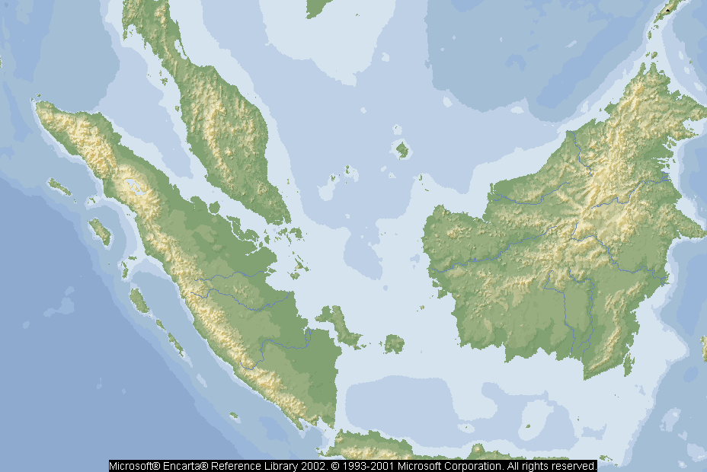
Malacca

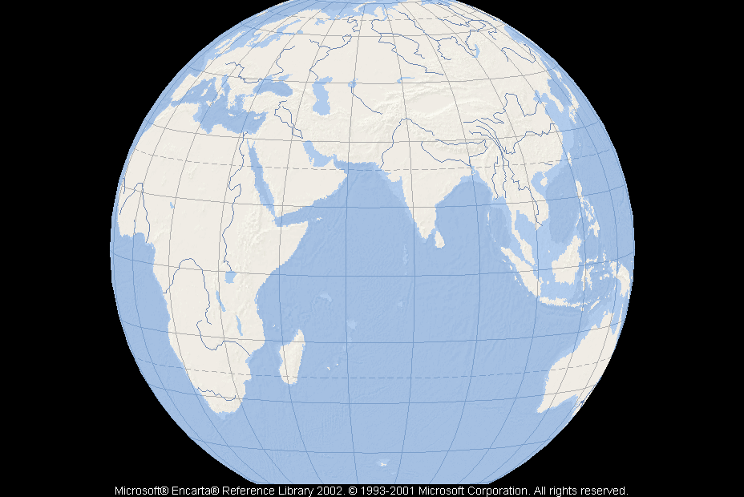
Malacca

Lesson 1
Student Handout 1.2—Global Convergence: Linking Together People, Resources, and Ideas

Factors that increased global convergence | Evidence of how these factors reflect global convergence. | Questions you have about the evidence of global convergence, 1400-1800.
Scientific, information, technological innovations.

Population changes, migration, and the environment.

Trade networks

Diffusion of crops and new commercial industries

States and empires

Lesson 1

Student Handout 1.3—Anticipation Guide: What Was it Like in the Trading Post in Malacca?

Directions: Before Europeans imposed themselves on the trading networks in the “luxury” trade of spices, indigo, silk, porcelain, cotton, pepper, sugar, and coffee, places where this trade was conducted, called entrepôts, that is, trading posts or transshipment centers, were well-established. These trading systems were made up of many entrepôts. Merchant communities, including Arabs, Persians, Chinese, Gujaratis, Malays, and East Africans, participated in these networks at the start of Big Era Six, 1400-1800. In this activity, you are asked to use this Anticipation Guide to predict what these trading posts were like. You decide whether the statements below are true or false. Be ready to explain your selection to the class. Then read the Case Study about one of the entrepôts of Malacca in Lesson 2. Following the reading, re-visit the Anticipation Guide to determine the accuracy of your original predictions.

True or False.

_________ 1. Because there were 80 different languages spoken on the streets of Malacca, few rules and procedures could be followed.

_________ 2. Traders came to Malacca to sell their wares and commodities but rarely bought items from there.

__________3. The Malaccan rulers, who ran these trading posts, charged high prices and demanded expensive tribute (gifts) for the privilege of trading at their post.

__________4. Only Malaccans were authorized and able to unload the heaviest goods from the traders’ ships.

__________5. Traders in Malacca missed their own native culture and suffered from not being able to eat their favorite foods while trading there.

__________6. Despite assurances from Malaccan authorities, traders did not feel that they or their cargoes were totally safe in Malacca.

__________7. Traders lived and ate on their ships while staying in Malacca.

__________8. We know about Malacca because one trader observed and wrote about his experiences there.

__________9. In Malacca, some traders were treated better than others.
Lesson 2
Trade Before the European Networks Were Established
Case Study of Malacca

Preparation

The purpose of this lesson is to introduce students to the ways in which the trading system generally worked before western Europeans arrived on the scene. Many entrepôts operated in the Spice Islands of what is today Indonesia and on the Malay peninsula. Malacca was one such entrepôt. Here merchants exchanged such goods as spices, cotton, tea, silks, foodstuffs, and other products that the Europeans could not get enough of in the fifteenth century.

Activity
1. Ask students to read the Case Study of Malacca (Student Handout 2.1). Students should observe how these trading networks were organized. At the conclusion of the reading, have students revisit the Anticipation Guide in Lesson 1 to compare their answers with the Case Study.

2. Give Students the Map Activity and Questions about Malacca (Student Handout 2.2). Ask them to work either individually or in small groups to complete the map activity and the related questions. Discuss some of the students’ maps and their answers to the related questions.
Lesson 2
Student Handout 2.1—Case Study of Malacca

Who were the people who traded at Malacca and from where did they come?
We know about the way in which the trading center at Malacca operated because in the sixteenth century, Tomé Pires, a Portuguese visitor there, observed and wrote about the traders who represented many different peoples and societies. Trading networks throughout Afroeurasia had operated for centuries, and though there were many different ports throughout the region, the focus of this lesson is on Malacca. Because of Pires’ description of his experience, historians have some idea of how the particular exchange network functioned.

Pires observed that many traders from all over Afroeurasia worked cooperatively side by side. Among the different traders who docked at Malacca, Pires identified:

Moors from Cairo, Mecca, Aden, Abyssinia, men of Kilwa, Malindi, Ormuz, Parees, Rumes, Turks, Turkomans, Christian Armenians, Gujaratees, men of Chaul, Dabhol, Goa, the kingdom of Decca, Malabars, Klings, merchants from Orissa, Ceylon, Gengal, Arakan, Pegu, Siamese men of Kedah, Malays, men of Pahang, Patani, Cambodia, Champa, Chochin China, Chinese, Legueos, men of Brunei, Lucoes, men of Tamjjompura, Laue, Banka, Linga (they have a thousand other islands), Moluccas, Banda, Bima, Timor, Maduyra, Java, Sunda, Pembang, Jambi, Tongkal, Indragiri, Jappatta, Menangkabau, Siak, Argua, Aru, Bata, country of the Tomjano, Pase, Pedir, Maldives.

While only a few of those peoples and places named above may be familiar to us today, we can tell that this was a diverse group, representing many regions and religions, though followers of Islam predominated. Pires describes the traders as getting along well despite the fact that they represented different global communities because they all had a “common culture of trade.”

At first, the key traders seemed to originate from China and India. The Indian ports of Gujarat and Cambay were well represented. According to Pires’ observation, “Cambay chiefly stretches out two arms, with her right arm she reaches towards Aden and with the other, towards Malacca as the most important places to sail to.” The traders referred to as “Gujaratees” had been Hindu, but as Islam had spread in the previous centuries, many had become Muslim. Gujarati traders from the coast of India continued to be active in this trading network until the late seventeenth century. Indian merchants from the Coromandel coast, that is, the southeastern eastern coast of India, as well as the southwestern, or Malabar coast, actively traded in the Malaccas as well.

The Chinese briefly dominated the region
Between 1405 and 1433, the Chinese government sponsored a brief and spectacular overseas venture. The Ming dynasty commissioned over sixty vessels and provided over 25,000 men under the command of the Muslim admiral Zheng He (1371-1435). He led his fleet to Malaya, Ceylon, and southwest India before his return to China. On later voyages, he traveled to Burma, India, the Persian Gulf, southern Arabia, and the coast of East Africa. These voyages stimulated trade between China and other regions because Zheng He brought home luxury items such as agricultural products, gems, metal, medicine, and cloth, as well as animals such as the ostrich, giraffe, lion, tiger, and zebra. Zheng He also established Chinese colonies in Java, Sumatra, and the Philippines. His biggest ships were ten times the size of the ships that Columbus commanded. Though Zheng He was in a position of making direct contact with Europe, the government of China decided in 1433 to sponsor these voyages no longer. Internal problems within China made these expeditions too expensive to continue, and the Chinese possessed much of what they needed. Therefore, Chinese leaders saw no reason to continue to support these voyages. The result was that Chinese sea merchants continued to trade, but mostly on routes between China and the Strait of Malacca. And Muslim merchants continued to dominate the Indian Ocean trade.

Although the Chinese government no longer “officially” supported these sea-going ventures, Chinese merchants had already established themselves in various trading posts and settlements. The Chinese presence was felt keenly in Malacca and elsewhere in the region, partly because of the legacy of Zheng He’s travels. Also, the voyages gathered much knowledge about the Indian Ocean world. This knowledge was represented in route maps, manuals, star charts, and other materials that escaped being burned by Ming officials and which fell into private hands.

Why was Malacca a preferred trading post?

Suppose you are a Gujarati trader with a cargo of cotton visiting Malacca. You intend to sell your cotton cloth and with the profit you will purchase a shipment of cloves and nutmeg to sell to merchants in India.

As a Muslim from India, you are comfortable in a trading system controlled by the Malaccan rulers, or sultans, who had recently converted to Islam. But you note that all traders seem welcome as well. As an Indian, you mingle with many other traders who represent markets in Asia and Africa. Perhaps you hear as many as eighty different languages spoken on the streets of Malacca, which are bustling with commercial activity. These other traders load cloves and nutmeg into their ships. A merchant approaches you about buying pepper, but you are not interested in pepper because it is produced on the Malabar coast of India as well as on Sumatra. So you can buy it in Malabar.

You have traded elsewhere but you prefer Malacca because the rulers are fair and impartial to the traders. This serves to encourage trade. The Malacca trading post is relatively safe and secure from marauders, and the fees the sultan charges for necessary business services are fair.

You need to feel safe because you brought a great deal of silver in order to purchase additional goods not covered by the sale of your cotton. Though gold is used, it is mostly silver that is an acceptable payment in this intercontinental trade.

Following your ship’s landing, one of four shabandars, or officials from the sultan, will be assigned to you. The shabandar will direct you to a residential area within the city which is administered by people from your home society. In these areas, you can speak Gujarati, find suitable lodging, and eat your favorite native foods. Gujarati foods are strictly vegetarian and you cannot wait to eat dishes made from basmati rice and seasoned with the fragrant spices, almonds, and the fresh vegetables you enjoy. You hope that you can purchase some freshly made chass or lassie, a liquid yogurt drink. And you would like to buy til gajak, a snack of sesame seeds cooked in thick syrup and then rolled and spread into a thin film and cut into pieces. In the local café, you can relax and exchange valuable information about prices and opportunities with other traders from your region.

The shabandars offer other important services that you will need in Malacca. An elephant can be obtained to help unload heavy bolts of cotton from your ship’s cargo hold. For reasonable fees, you can store your cotton cloth until it is sold. To make sure that your goods are safe and secure from thieves, you can buy protection services. All entrepôts charge fees for the privilege of doing business, but you believe that the fees and duties (taxes) that you are charged are among the fairest. Even the “gifts” you must bring to the sultan do not have to be as high in value as those required in other ports. A committee comprised of your own community members and Malaccan officials help ensure that you receive a fair price for your cotton. Should a problem or dispute arise, as often happens in trading cities, officials from your own cultural community have jurisdiction (authority) so your own laws with which you are familiar bind you. For all of these reasons, you enjoy trading at Malacca.
Lesson 2
Student Handout 2.2—Map Activity and Questions about Malacca

Directions: After reading and discussing the Case Study of Malacca, use this map to find the locations for selected places presented in the reading. Students should have colored pens or pencils to complete this assignment. Then, answer all of the questions related to trade at Malacca.

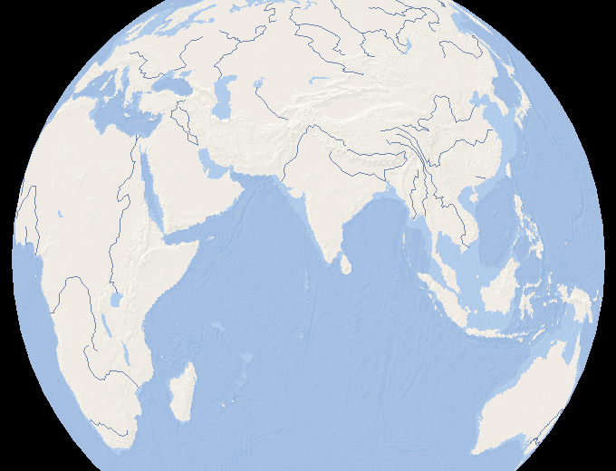
Microsoft® Encarta® Reference Library 2002. © 1993-2001 Microsoft Corporation. All rights reserved.

1. Locate Malacca on the map.

2. The Portuguese mariner Tomé Pires identifies traders from many regions throughout the Afroeurasian world. Among these are traders from:

- Abyssinia (Ethiopia) | - Gujarat
- Aden | - Java
- Cairo | - Kilwa
- Cambodia | - Malabar
- Ceylon (Sri Lanka) | - Malaysia
- Guangzhou (Canton) | - Mecca
- Goa | - Timor

Find these places and print their locations on the map.

3. Identify and print the following on the map:

- Indian Ocean
- Bay of Bengal
- South China Sea
- Arabian Sea

4. Determine the best route for these traders to travel from their home port to Malacca. Mark the route you choose in the color associated with each home city or region.

- Abyssinia (Ethiopia) - red | - Guangzhou (China) - black
- Cairo - green | - Gujarat - yellow
- Ceylon (Sri Lanka) - blue | - Java - brown

(Optional: Students may also research the kinds of products these traders brought to Malacca.)

5. Using a dotted red line, trace the voyage of Zheng He, the Chinese admiral who sailed the Indian Ocean from 1403 to 1433 under the sponsorship of the Chinese Ming Dynasty.

6. What parts of the Eastern Hemisphere may have been completely excluded from these international trading activities? How might these exclusions be explained?

7. In the reading, we learned that a diverse group of traders at Malacca seemed to get along because they shared “a common culture of trade.” Explain what you think that phrase means and how that “common culture” would influence the traders’ behavior toward one another?

8. In the Case Study, one religion appears to have been spreading along the trading network. What religion seems to predominate and why do you think that this was the case?

9. Gifts and “tribute” had to be brought to the sultan of the trading port. What kinds of items do you think the sultan would have appreciated receiving?

10. Optional: With a partner or individually, create a brochure advertising the benefits of being a merchant at Malacca. Review the Case Study of Malacca for details. Include the location of Malacca somewhere on your brochure to show the relationship of the location to other continents. Create quotes by “satisfied” traders who identify Malacca as their favorite trading post. Describe the services offered to traders as well as the kinds of goods offered there for sale. Perhaps you can research other entrepôts and compare the experience of trading elsewhere with the benefits of trading at Malacca. When completed, display your brochure in the classroom.

Lesson 3
Hunger for Spices

Introduction
Students today may not fully understand the intense desire people had 500 years ago for the commodities that we take so much for granted. The desire for sugar, tea, pepper, spices, and other commodities are behind the enormous drive that pushed the Europeans to risk life, limb, and fortune to establish closer contact with the sources of these goods. Europeans went in search of trading centers such as Malacca in order to satisfy the growing demand of their own populations.

Student texts usually describe sugar, tea, pepper, and other spices as “highly prized.” But students may have difficulty understanding what that descriptive term means. In the reading titled “Spice It Up,” students learn how people used these commodities and in some cases consumed to maintain their health. For example, people sometimes guarded peppercorns against theft.

Following the “Spice It Up” reading, students should complete the “Three-Level Guide.” This guide helps students think about texts on the literal, interpretive, and applied levels. Three-level guides facilitate students’ comprehension by moving from lower to higher levels of comprehension. Students may also use the Three-Level Guide to write questions for other readings.

Three-Level Guide

Level I - Literal
At the Literal Level, students identify information they should know after reading the text. The information focuses on explicit ideas that were clearly presented in the text. Level I questions might be worded as “who, how, or what” questions.

Students should identify those statements that were presented in the text. Students should think about the facts presented in the reading and go back to verify where the text agrees with the Level I statement that students make. Remind students to locate the places in the text that support their responses. Example: Why did drinking tea provide benefits for one’s health? (Students might conclude that the act of boiling water for the tea substantially reduced harmful germs.)

Level II - Interpretive
At the Interpretive Level, students find information that they should understand after reading the text. The text contains inferences or other examples of “reading between the lines.” Though the answer can be determined within the text, it often requires some analysis. Teachers may model how to respond to the interpretive level statement by using examples from the content area.

Level II questions are usually worded as “why” questions. Example: Why did many Europeans believe that good health was dependent on a balance of the fluids, or “humors,” in one’s body?
(Answers will vary but might include the idea that people’s knowledge of medicine was limited during this time and that belief in humors was common in Europe during Big Era Six.)

Level III - Applied
At the Applied Level, items are presented from the reading that the students should consider. These ideas go beyond what is written in the text and require students to use information, express opinions, and create new ideas. There may be no single right answers to Level III questions. They are open-ended and designed to provoke discussion. Example: Do we feel the same way today as Europeans did 500 years ago about acquiring quantities of spices? (Students might be provoked to discuss current concerns about gasoline prices and certain medications or other goods that concern them. Or they may conclude that the global trading networks in the modern world provide everything we need. Discussion could turn toward the examination of the concepts of supply and demand and of strategies for obtaining goods.)

Activity
Have students write answers to the Level I, II, and III questions on Student Handout 3.2 in groups. Remember that Level III responses may have no right or wrong answers. Ask students to trade their questions with the other groups and test the other student groups’ comprehension. It is recommended that the teacher review the questions before they are traded to ensure that they are clearly worded and fit into the appropriate Level categories.

Lesson 3
Student Handout 3.1—Spice It Up.

“No man should die who can afford a cup of tea.” This belief was prevalent in some European cities as the practice of drinking tea became fashionable among the wealthier classes of society. By the end of Big Era Six (1400-1800), tea became more available, but in the fifteenth century, few could afford it, even though many people believed in its restorative powers. Historians believe that perhaps the health properties of tea may have been mainly due to boiling and purifying water. But as demand for this product grew, so did the pressure on merchants to supply it.

Many Europeans believed that good health depended on a balance of the fluids or “humors” in one’s body. It was further believed that by adding spices to one’s food, these humors were put into balance. Spices such as cinnamon, cloves, ginger, nutmeg, mace, saffron, and pepper were in high demand in growing European cities, but only a minority could afford them. As Big Era Six opened, Arab traders sold their cargoes of these precious goods to Italian shippers, who, in turn, sold them to people in European towns and cities. Other merchants, in addition to Arab traders, such as Indian, Chinese, and Malay, were actively trading as well, as we have seen in our Case Study of Malacca. Each time these goods changed hands, their price increased.

In additional to medicinal purposes, spices were highly desired to add flavor to foods, to preserve meats (no refrigeration), or to conceal the flavor of partly spoiled meat. Spices were used to produce medicines, perfumes, and dyes, and to flavor drinks. Wealthy ladies sometimes carried ginger around their necks in order to sweeten their breath.

Sugar was another highly desired commodity. Produced on a large scale in India and Southwest Asia and exported by Arab, Indian, and Persian merchants, it attracted the palates of the European Crusaders who went to Southwest Asia on military expeditions between the eleventh and fourteenth centuries.

But who would have thought that one of the most highly desired spices was a small, black, wrinkled berry called pepper? The sale of pepper in the market-place required the same kind of protection for the commodity as one might expect for an expensive jewelry store.

Pepper merchants sell their product individually, by the peppercorn; because of its expense, a housewife was able to buy just one peppercorn if she wished. The popularity and costliness of pepper resulted in its being guarded like diamonds. Longshoremen, [who unload ships and] who handle the peppercorns are closely watched and frequently searched. Crossbows and blades of the guards bristle on the galleys that bring the pepper through the Mediterranean. . . . But these precautions do not protect the pepper from being tampered with by grocers, wholesalers and middlemen, any of whom may mix a bit of something with it making a few fake peppercorns. They were made to look like peppercorns by using some clay, oil, and mustard, which was difficult to distinguish from the genuine peppercorn.

Many Europeans could not afford peppercorns or any spices. Others used them only for special occasions, such as weddings. In richer homes, the spice cabinet was kept locked.

Other products sought from the Asian-centered trading networks included manufactured goods as well: rugs, Chinese lacquer-ware, and cotton cloth which was more comfortable and lighter than clothing made out of European wool. Some of the names for cotton fabrics we use today can be traced to their place of origin:

The very names by which cotton fabrics are known in English and other European languages reveal the places from which they were thought to come. “Madras” and “calico” refer to the Indian cities of Madras and Calicut, “muslin” to the Arab city of Mosul. “Gingham” comes from a Malay word meaning “striped,” and “chintz” from a Hindustani word meaning “spotted.”

The demand for cotton textiles was so high that those involved in the wool, linen, or silk commercial ventures in Britain pressured for laws that would forbid the importation of these fabrics. Daniel Defoe observed in 1780: “Despite the laws, cottons were not only sought as clothing by all classes, but crept into our houses, in our closets, and bedchambers; curtain, cushions, chairs and at last beds themselves were nothing but calicoes or Indians stuffs.”

This, then, is essentially the picture at the beginning of Big Era Six. Europeans simply did not have access to the knowledge of the spice routes and trading networks that were known to the Chinese, Arabs, Indians, and Africans. Even if they did, the Europeans did not have the maritime technology, skills, and knowledge needed to participate in these oceanic ventures in the early fifteenth century. Despite being sought after, the control of these commodities remained in the hands of non-Europeans who essentially controlled the supply and price.

But the word beginning is stressed because soon after it began, Europeans borrowed basic maritime technology, such as the compass and stern-post rudder from China, the Arab lateen sail, and Muslim charts and maps. By the time Big Era Six drew to a close, the situation changed dramatically. It is important to note that while Europeans were in conflict with non-Europeans, they were also in conflict with each other. They competed for trade in Asia and the Americas, and their efforts to establish markets, conquer, and drive out competition, often led to clashes. These commercial and political rivalries led to wars between ships flying different flags. European warfare dominated much of Big Era Six.
Lesson 3
Student Handout 3.2—Three-Level Guide For “Spice It Up.”

Students should think about the reading in Student Handout 3.2 and move from lower to higher levels of comprehension in answering the questions:

I. Literal Level
Answer these questions by finding the information from Student Handout 3.1, “Spice It Up.”

______1. In the early part of Big Era Six (1400-1800), what did wealthier Europeans believe adding spices to their diet would do to improve their health?

______2. What was one of the most highly prized spices during this era?

______3. Which ethnic and language groups controlled the luxury trade in spices and certain commodities at the start of Big Era Six?

II. Interpretive Level
In this set of statements, the author may not have elaborated or explained what is meant in detail. Find the place in the text where these statements were made. Provide an explanation using both the information from “Spice It Up,” and knowledge that you or your group have.

______1. What evidence is there in the reading suggesting that the use of spices was reserved mostly for wealthier Europeans?

_____2. For what reasons did longshoremen, grocers, wholesalers, and middlemen have to be watched when they came in contact with peppercorns?

_____3. Why do you suppose that producers of woolens, linens, and silk were able to get the English government to make laws to forbid the importation of cotton fabrics?

_____4. Why were Europeans unable to obtain the spices and goods in the quantities they desired for themselves at the beginning of Big Era Six?

III. Applied Level
After reading “Spice It Up,” answer these questions with a group of students or with the entire class. These are open-ended questions for which there may be no right or wrong answer. They are meant to foster discussion. Not everyone may agree, but through the activity of discussion, some interesting ideas should emerge. It may be necessary to set some ground rules before the class begins a discussion over topics that may be controversial to some.

______1. Is one group of people justified in taking over the trading and commercial networks from other groups of people, such as the Europeans did when they entered the Indian Ocean in their ships?

______2. Do we have any beliefs today that you think are as misguided as ideas that people 500 years ago thought were true regarding the healthy properties of spices?

______3. Do you believe that people today have needs to acquire costly and highly desired possessions in the same way that Europeans wanted spices, fabrics, and other exotic products during Big Era Six? What are some items we prize today?

______4. How could it have been possible for Europeans and other peoples to work together in trade and share trading networks for the prized commodities we have read about? To what extent do you believe cooperation could have been successful?

Lesson 4
Europeans in the Indian Ocean

Introduction
In the last reading, students learned about the spice trade, one of the sources of pressure on Europeans that led them to adopt many important items of maritime technologies from Arab and Chinese mariners.

With these technologies and acquired knowledge of wind patterns and sea currents, Iberians, that is, Portuguese and Spanish, whose countries occupied the Iberian Peninsula, began their explorations. Because they could sail farther and surer than in the past, Europeans, specifically Christopher Columbus and his crew, “stumbled” into the Americas during their quest for routes to Asia and the Spice Islands. This discovery was a boon to Europeans, especially the Spanish, because they gained access to the rich silver mines in Bolivia and Mexico. They used this silver to purchase spices, as well as many products from China.

In the reading that follows (Student Handout 4.1), students will learn how European methods and strategies for trade contrasted with the way commercial networks worked in the Indian Ocean region in previous centuries, for example the entrepôt trade through Malacca. Textbooks usually provide abundant information concerning the European period of exploration. Here, the intent is not to tell that story. Rather, students should come away from this reading with knowledge about the change in methods and strategies employed by the Europeans as they sought to gain control of valuable trading networks, and the human and environmental costs that resulted.

Activity
Following the reading, ask students to write a dialectical journal entry based on the information provided in Student Handout 4.2. A dialectical journal is a process by which students can interact with the text in a variety of ways. It is also a way for students to take notes on informational texts and add their own reflections. There are many different dialectical journals students can use. The journal students will use here requires them to speculate about effects and make predictions. By using the journal, students should be able to look at the informational text at different levels and points of view.

Lesson 4
Student Handout 4.1—Cannon to the Right of Us, Cannon to the Left of Us: How Shipboard Cannon Changed the Rules

The Portuguese
Vasco da Gama reached India, though only half of his crew would make it safely back to Portugal. His cargo of pepper and cinnamon was so profitable that, despite these crew losses, Portuguese merchants began to push for more expeditions. They wanted to control trade routes by forcing merchant vessels to land at their trading sites and pay duties or fees to them. A trading post was established at Calicut in 1498. By the mid-sixteenth century, the Portuguese had more than fifty trading posts between West Africa and East Asia. They traded for West African slaves and tried to control the southern African gold trade. From Hormuz, located on the Strait of Hormuz leading from the Arabian Sea to the Persian Gulf, they seized control of access to the gulf. From Goa on the western coast of India they organized export trade in pepper. Finally, at Malacca, they oversaw shipping between the South China Sea and the Indian Ocean. They established posts in the Ternate spice, also at Macau off the coast of China and near Nagasaki in Japan.

How Did They Do It?
The Portuguese ships were relatively small and light, but they had one great advantage: shipboard cannon. Their vessels had sturdy rib construction so that the recoil from the heavy cannon did not blow them apart. The non-European ships that plied the Indian Ocean were built differently and did not traditionally carry large firearms. After the Portuguese arrived, Muslim and other traders in the Indian Ocean began to install shipboard cannon but not before the Europeans won many sea battles.

The Portuguese soldier Afonso d’Albuquerque (1453-1515) battled for Hormuz. The excerpt below describes the methods the Portuguese used to take over the spice trade. They seized cities and built military and trading posts in the Indian Ocean. For about fifty years, Portugal controlled the spice trade between Europe and Asia. The following represents an eye-witness account of the methods employed by the Portuguese under the command of Albuquerque:

When Afonso d’Albuquerque perceived the gleaming swords and waving of the bucklers and other doings of the moors [Muslims] on shore, . . . he ordered a broadside to be fired. The bombardiers took aim so that with the first two shots they fired they sent two large ships which were in front of them, with all their men, to the bottom. Manuel Telez, after having caused great slaughter upon some vessels, . . . ran into a large vessel that lay close to him and killed a part of the men in it, while the rest threw themselves into the sea, and those who were heavily armed went down at once.

After the Portuguese came Spanish, Dutch, French, and British expeditions. Because European traders were often backed by their governments, which sought new riches as a way to give them a competitive edge in an increasingly competitive European state system, they “gate crashed” the commercial networks of South and Southeast Asia similarly to the way that Mongol armies had taken over the trade of the silk roads three centuries before.

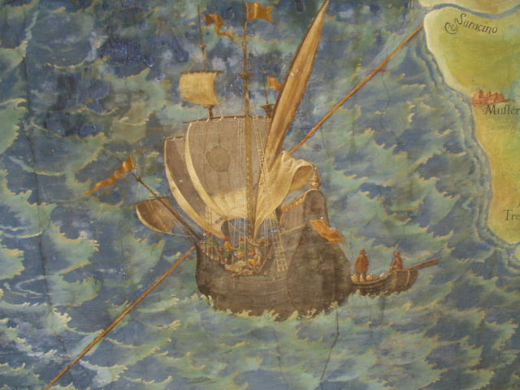

European Sailing Ship, Sixteenth Century
Vatican Museum
Photo R. Dunn

Lesson 4
Student Handout 4.2—Dialectical Journal

To write a journal, examine the events in the reading and speculate on or predict the possible long-term effects or results of these events. In the left-hand column, select at least three passages from the reading and record what occurred. In the right-hand column, write what might or should have happened as a result of the information recorded in Column One.

What Happened? | What Might/Should have Happened as a Result?
1 | 1
2 | 2
3 | 3

Lesson 5

The Columbian Exchange

One of the fundamental consequences of the Great World Convergence was the Columbian Exchange, that is, the transmission of plants, animals, and microorganisms between Afroeurasia and the Americas. In study of Big Era Five, specifically Lesson 6 of the Panorama Teaching Unit, students learned about the movements of food and fiber crops from one part of Afroeurasia to another. These included coffee, citrus fruits, cotton, sugar cane, wheat, and rice. In this lesson on the Columbian Exchange, students will learn about the worldwide diffusion of some of these and other plants, plus animals and microorganisms. The Columbian Exchange represents perhaps the most dramatic consequence of global convergence in the sixteenth century.

Students should be familiar with the “explorers” that most textbooks describe in detail in connection with Portuguese, Spanish, Dutch, French, and English voyages. The purpose of this lesson is not to duplicate that information but to get students to think about the “biological” exchange that took place as a result of the opening of oceanic passages.

Share with students the idea that our global economy and the availability of all kinds of foods have led us largely to ignore the origins of items we eat just about every day. Many of those foods reach us from tropical regions thousands of miles away. In fact, we have the privilege of eating many fruits and vegetables all year long. We do not have to wait until they are “in season.”

Procedure
Ask students to share with the class their favorite foods. Have a student make a list of responses on the board. When appropriate, ask about the ingredients necessary to make a certain dish, such as tomato sauce, which is necessary for pizza. After generating the list, distribute Student Handout 5.1, which asks students to identify the origin of selected foods, fibers, and animals. Give one questionnaire to a pair or small group of students or make an overhead and elicit answers from the entire class.

As an option, form the class into two teams, one on each side of the classroom. Have each team choose from three to five “players.” Give all players sheets of paper or cardboard placards with AF (standing for Afroeurasia) written on one side and AM (standing for the Americas) on the other side. Have the players stand in front of their teams. The teacher should then read the name of an item on the Student Handout 5.1 list. The players must quickly decide whether the item named was originally from Afroeurasia or from the Americas, then hold up their cards with the appropriate letters facing forward. The team with the most players who hold up the right answer receives 1 point. When all the items on the list have been put in play, the team with the most points wins the contest. As the items are named, the teacher might make a comment about the particular item, for example, the fact that sugar, an Afroeurasian crop, became closely associated with African slave labor in the Americas.

After students become familiar with the origins of some plants and animals, ask them to read Student Handout 5.2 (Importance of the Columbian Exchange) to learn about the importance of the Columbian Exchange both in the period when it occurred and today. Discuss this information in class. Teachers may use the key below to check student answers

Ask students to study Student Handout 5.3 (Contemporary Regional Effects of the Columbian Exchange), then answer the questions and do the activities that follow.

Key for Teachers on Plant, Animal, and Pathogen Origins

Origin in the Americas  Crops  Manioc  Cassava  Beans (also known as legumes such as wax, pinto, pink, kidney, lima)  Cacao tree (cocoa)  Corn  Sweet corn  Pumpkin  Peanut  Peppers (sweet and hot; chili and cayenne)  Pineapple  Potato  Squash  Strawberry  Sunflowers (used for oil, seeds; they are rich in protein)  Tomato  Avocado  Guava  Papaya  Passion fruit  Tobacco  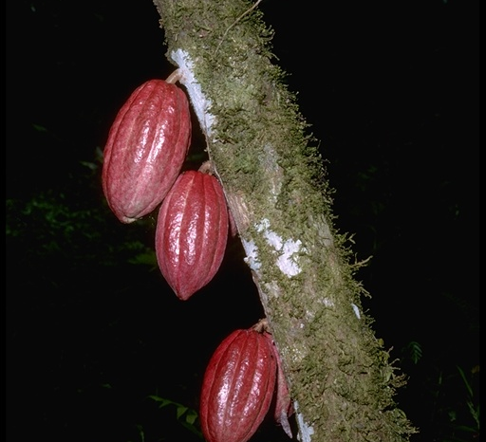  Cacao Tree  H. Vannoy Davis © California Academy of Sciences  Animals  Dog  Llama  Alpaca  Guinea pig  A few species of fowl  Turkey  Raccoon  Chipmunk  Hummingbird  Rattlesnake  Skunk  Pathogens  Probably syphilis | Origin in Afroeurasia  Crops  Beet  Broccoli  Cabbage  Brussels sprout  Carrot  Eggplant  Okra  Onion  Pea  Sorghum  Soybean  Yam  Mulberry  Pomegranate  Tamarind  Cherry  Black pepper  Cinnamon  Coffee  Loquat  Banana  Clove  Ginger  Parsley  Coriander  Leechee  Oregano  Rice  Wheat  Barley  Rye  Turnip  Onion  Lettuce  Peach  Pear  Orange  Olive  Sugar  Cotton  Animals  Dog  Horse  Donkey  Pig  Cattle  Goat  Sheep  House Cat  Starling  Barnyard fowl  European brown and red rat  Pathogens  Smallpox  Malaria  Yellow fever  Measles  Cholera  Typhoid  Bubonic plague  Tuberculosis  Common cold  Chicken pox
Lesson 5

Student Handout 5.1—Global Food Exchanges

Directions
The purpose of this exercise is to determine if you can identify whether the food, fiber, and animals are from the Old World of Afroeurasia or from the New World of the Americas. In some cases, you may know the origin of these items, and in other cases you will have to guess. Through the activity and reading, you will gain an appreciation of the contribution made by the new foods, fibers, and animals that continue to support the world’s population. In the meantime, test your knowledge and see how many of these Old World items you can guess correctly. If you think the item listed is from the Old World, write “O” in the space. If you think the item is from the New World, write an “N” in the blank.
_____1. turnips
_____2. potatoes
_____3. broccoli
_____4. avocado
_____5. peanuts
_____6. peas
_____7. yams
_____8. coffee
_____9. cinnamon
____10. sunflowers
____11. rice
____12. oranges
____13. mint
____14. corn
____15. donkeys
____16. guinea pigs
____17. sugar
____18. cotton
____19. tobacco
____20. cacao (for chocolate)
____21. horse
____22. avocado
____23. wheat
____24. turkey

1. What are your three favorite foods? List them.
A.
B.
C.

2. Analyze the ingredients to find out whether they are from the Old World, the New World, or both.

3. If you had to live in a world with the foods of either the New World or the Old World, which would you choose? Explain why?

4. Keep a journal of foods you eat for a day. Cross out those items that would not be available in North America had the worldwide exchange not taken place. Diagram on a map where the various foods you are eating were first grown.

5. Trace the “travels” of one item from the flora (sugar, coffee, cassava, corn, potato) and one from the fauna (horse, cattle, chicken, pig) from one part of the world to another between the sixteenth and the eighteenth centuries. Analyze the impact of these on world economic change.

6. (Optional) Research the effects of the horse, sheep, and pig on life in the Americas. How did it change farming and ranching?

Lesson 5

Student Handout 5.2—Importance of the Columbian Exchange

One American Crop Has an A-maizing Global Impact
The global spread of foods originating in the Americas has been staggering. Corn and potatoes fed a hungry Europe while Africa and Asia quickly adopted other American food plants. Maize, or corn, is a drought-tolerant food. It stores well and gives needed calories. Maize traveled to Morocco and West Africa in the sixteenth century. From there, it was adopted in Egypt and parts of the Ottoman empire. Maize spread to Africa in the seventeenth and eighteenth centuries and became an important food in South Africa. Maize continued its travel to Southeast Asia and China where it was used in peasant diets.
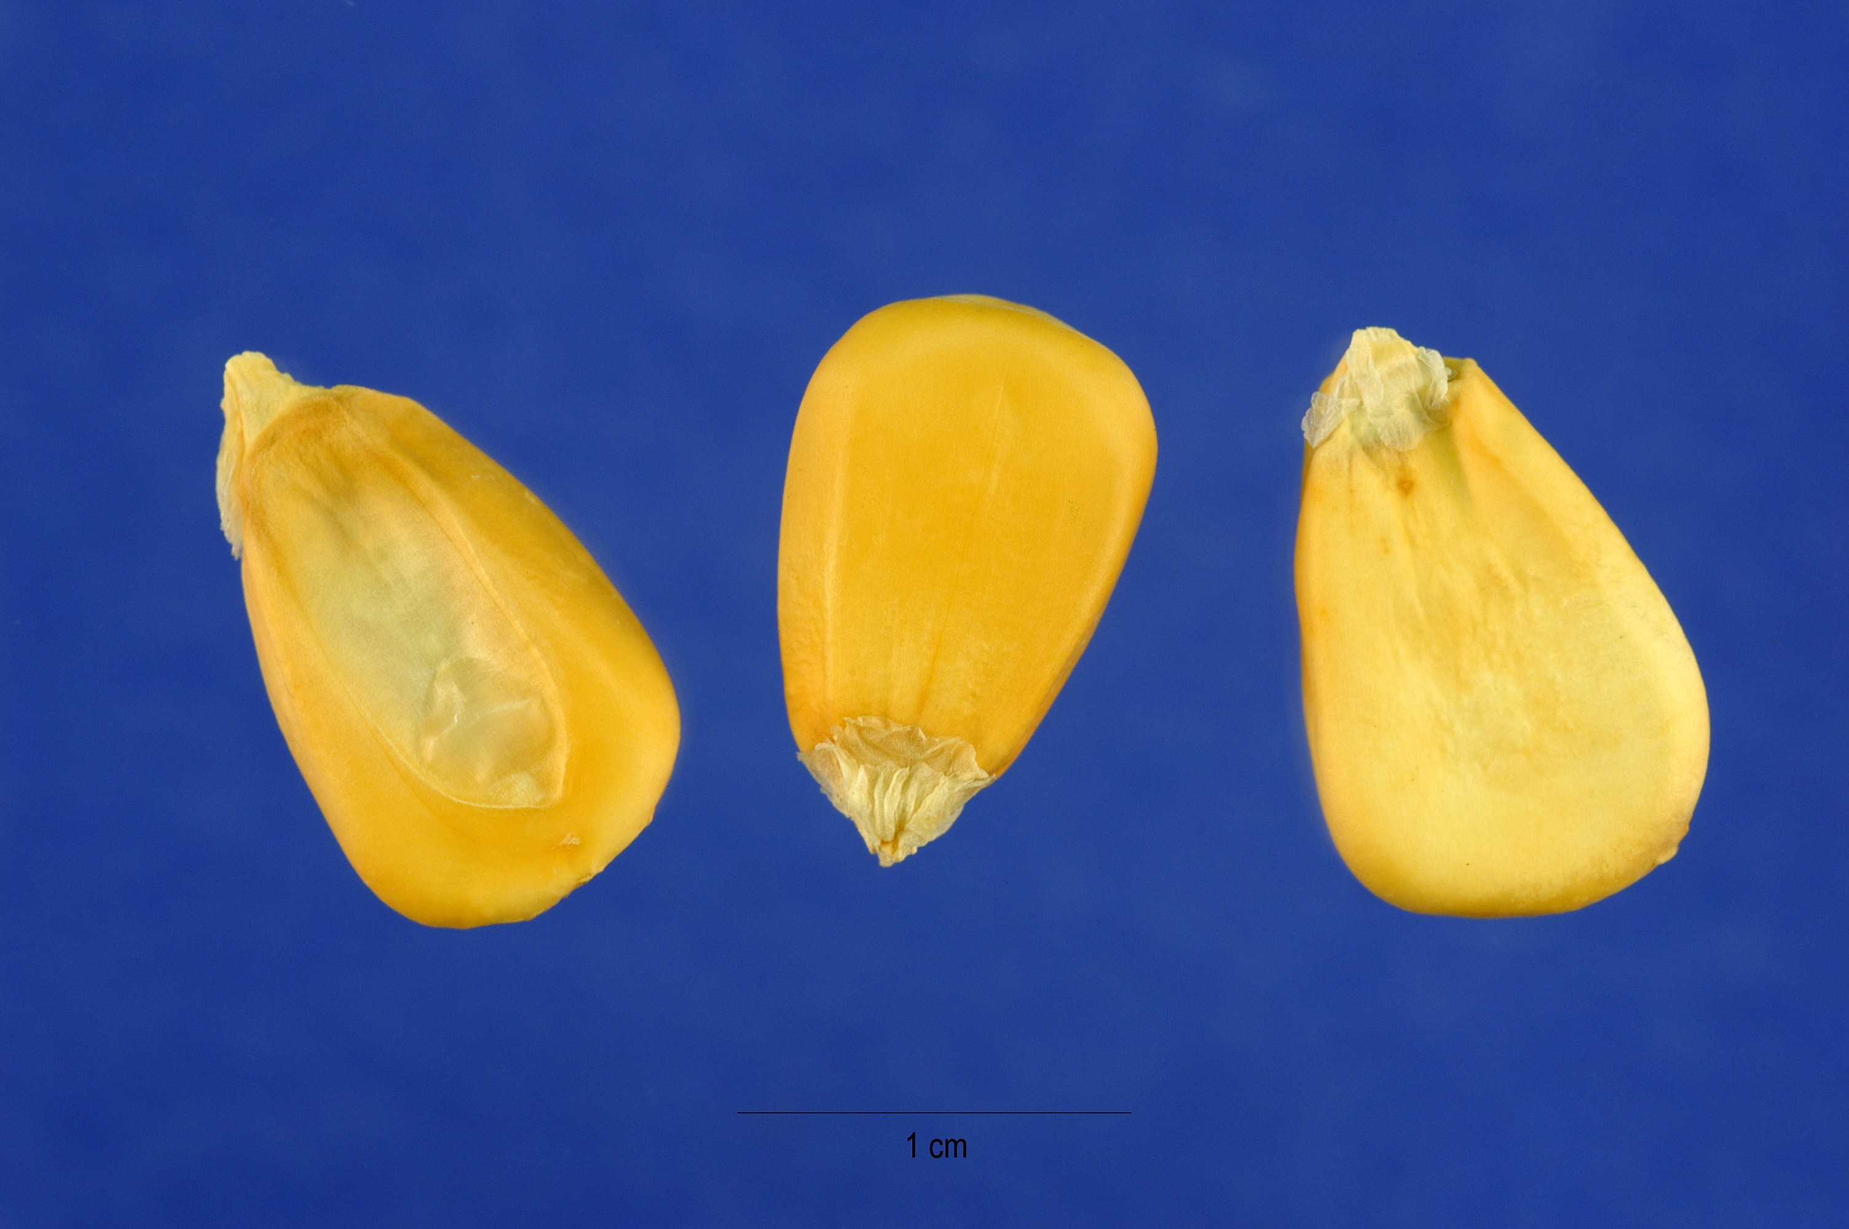

Steve Hurst @ USDA-NRCS PLAN
http://plants.usda.gov/gallery/pubs/zema_002_php.jpg

Caloric Cassava, or the Mighty Manioc
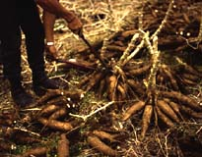
Cassava, also called manioc, is a tropical plant with edible roots. The root is tuber-like and similar to a potato when boiled. Cassava or manioc is a native of Brazil but grows in any tropical environment. When this food was transferred to Africa, it spread from Angola to West Africa and became a main food yielding important calories. Most of us who live in a temperate climate zone know of this food crop as “tapioca” and enjoy it as a dessert. However, manioc has become a vital food crop to those who live in the tropics. The manioc plant is a large shrub and is harvested when it reaches between five and twelve feet. The leaves can be eaten, but the roots, which can grow up to two feet long, are the most prized as a foodstuff. Poor and dry soils do not adversely affect this food, nor do pests that ruin other crops. In parts of the Congo, manioc will yield five tons per hectare of land that cannot support maize. Chiefly a starchy food, it contains vitamins and other important nutrients. It is bountiful and grows either in dry or rain-drenched lands.

Photo by David H. Byrne, Texas A&M University
http://aggiehorticulture.tamu.edu/features/costarica/cassava.html

The Potent Portable Potato
The potato, originally from the Andes Mountains, spread throughout the world as an important food crop, staving off famine in various regions. The potato became a mainstay in Ireland and Northern Europe and Russia. At first, Europeans regarded the potato with fear and dread. They believed, for example, that it could cause leprosy or that it might lead to “rot and gas.” But the Irish adopted the potato in the last years of the sixteenth century. The soil was favorable to its growth in Ireland. Living in poverty and malnourished, the peasantry regarded it as a “gift.” It would grow on a small amount of land and nourish a family quite well. While the potato became a staple in Ireland, it also caught on in England by the eighteenth and nineteenth centuries as the industrial revolution brought more people to the cities. It spread to France on the European continent, where it enjoyed new prestige and was even served at the royal table of Marie Antoinette. The potato was adopted in Hungary after a famine in 1772 and became an important crop in eastern Europe. It was Catherine the Great, Empress of Russia, who promoted its adoption in Russia. After severe failures of other crops in 1838 and 1839, the potato gained in popularity. By 1900, Russia was one of the world’s top potato producers. It continues to be so today.

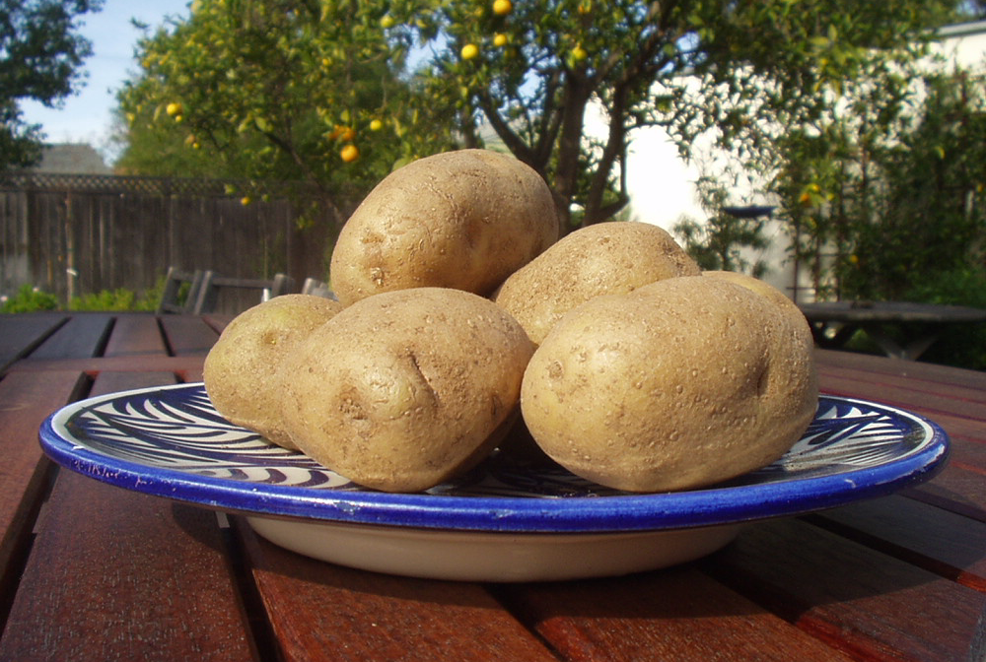

Photo by R. Dunn

What About the Rest of Us Foods? (We’re Not Chopped Liver!)
Other foods from the Americas also diffused throughout the globe. These include the sweet potato, peanuts, cacao, pineapple, squashes, beans, tomatoes, and several other plants. Africa, Indonesia, China, and Europe all benefited from these new foods.

What Old World Foods Went To The Americas?
Food crops that went from Afroeurasia to the Americas were part of the Columbian Exchange, but in the opposite direction. These included wheat, oats, barley, and citrus fruits. When grown on the immense plains of the Americas, these food crops transformed farming after the sixteenth century. Plantation owners also made huge profits growing Old World “cash crops,” notably sugar, coffee, and cotton. Between the sixteenth and nineteenth centuries, slaves brought by force from Africa grew most of these commercial crops. The horse, an Afroeurasian animal, transformed life for plains Indians in the Americas, and cattle ranching spread across North America, Brazil, and Argentina.
Lesson 5
Student Handout 5.3—Contemporary Regional Effects of the Columbian Exchange

What do the chief crops listed tell you about the Columbian Exchange? Answer the questions and do the activities listed below the chart.

AFRICA | MIDDLE EAST | CHINA | EUROPE | AMERICAS
Liberia | Iraq | China | France | Brazil
Capital: Monrovia  Population: 3,225,837  Geography:  On SW coast of W. Africa  Chief Crops:  Rice  Cassava  Coffee  Cacao  Sugar | Capital:  Baghdad  Population:  23,331,985  Geography:  The Middle East  Chief Crops:  Grains  Dates  Cotton | Capital:  Beijing  Population:  1,273,111,290  Geography:  Occupies most of the inhabitable mainland of E. Asia  Chief Crops:  Rice  Cotton  Potatoes  Tea | Capital: Paris  Population  59,551,227  Geography: Western Europe  Chief Crops:  Grains  Sugar Beets  Wine grapes  Potatoes  Vegetables | Capital: Rio de Janeiro  Population  174,468,575  Geography: Occupies Eastern half of South America  Chief Crops:  Soybeans  Coffee  Rice  Corn  Cocoa  Citrus
Nigeria | Jordan | Indonesia | Ireland | Costa Rica
Capital: Abuja  Population:  126,635,626  Geography:  Tropical West Africa  Chief Crops:  Cacao  Corn  Rice  Cassava  Yams | Capital: Amman  Population:  5,153,378  Geography: Middle East  Chief Crops:  Grains  Olives  Fruits | Capital: Jakarta  Population: 228,437,400  Geography:  Equatorial Southeast Asia  Chief Crops:  Rice  Cacao  Peanuts  Rubber | Capital: Dublin  Population:  3,840,838  Geography:  Northeastern Atlantic west of Britain  Chief Crops:  Potatoes  Sugar Beets  Turnips | Capital: San Jose  Population: 3,773,057  Geography:  Tropical Central America  Chief Crops:  Coffee  Bananas  Rice  Potatoes
Zimbabwe | Saudi Arabia | Vietnam | Slovakia | United States
Capital: Harare  Population:  11,365,366  Geography:  Southern Africa  Chief Crops:  Tobacco  Sugar  Cotton  Corn  Wheat | Capital: Riyadh  Population:  22,757,092  Geography: Most of Arabian peninsula in Middle East  Chief Crops:  Dates  Wheat  Barley  Tomatoes  Melon  Citrus | Capital: Ho Chi Minh City  Population:  79,939014  Geography:  Southeast Asia  Chief Crops:  Rice  Potatoes  Soybeans  Coffee  Tea  Corn | Capital: Bratislava  Population: 5,414,937  Geography: East Central Europe  Chief Crops:  Grains  Potatoes  Sugar beets  Fruits | Capital:  Washington, DC  Population:  278,058,881  Geography: North America  Chief Crops:  Cotton  Wheat  Corn  Sugar  Fruits

Chart data source: The World Almanac and Book of Facts (New York: World Almanac Books, 2002)
1. Based on the chart above, what general statement can you make about the effects of the Columbian Exchange on the world today?

2. Is there a country (or countries) on the chart that has not adopted any crops from the New or Old World?

3. Is there one (or more) country on the chart that has adopted one or more non-native crops? If so, which crops?

4. If you were an official in a region near the Equator that is facing a food shortage owing to drought or poor soil, what crops might you recommend to farmers to grow? How would you persuade the farmers to change? (Refer to the Student Handout 5.2 for information.)

5. Research other countries in a variety of regions around the globe. Make a list of those countries whose chief crops appear to reflect no influence from the Columbian Exchange. Make a list of those countries that have been the most affected by crop diffusion because of the Columbian Exchange. What are their chief crops? Explain your findings.

6. Nominate a crop that, based on the information you have read, has provided important nutrients and calories to the world. Make a poster in which you draw the crop you select and advertise its benefits and effect on the peoples of the world.

Lesson 6
The Great Dying and Its Relationship to Slavery in the Americas

The positive effects of the Columbian Exchange included more nutritious and high-calorie foods available to a hungry world. Additionally, a great deal of information about the flora and fauna of the Americas provoked many questions and stimulated research and study. But the linking of societies around the world had a negative side to it, including drastic population decline of American Indian populations and the rise of the Atlantic slave trade. Students should study these developments by examining the demographic (population) changes that occurred to better understand the exploitation and brutalization that followed the Great World Convergence.

Procedure
Discuss with students the idea that the Columbian Exchange had both positive and negative consequences. During Big Era Six, some societies came to dominate and exploit others, and the legacy of these inequities lingers today.

The Native American populations were ravaged by Afroeurasian diseases against which they had no immunities. Because of their geographic isolation from Afroeurasia before 1492, American Indians had no antibodies to protect them from common Afroeurasian diseases. “The Great Dying,” as it became known, caused massive upheaval in the lives of indigenous Americans, from Alaska to Argentina.

Partly because of the radical decline of the American Indian labor pool, European entrepreneurs who wanted to develop mining and commercial agriculture in the Americas, brought Africans across the Atlantic as forced labor. These slaves died in large numbers during the passage, and those who arrived often succumbed to disease or to the brutality of their overseers within a few years. Despite high mortality, African slaves tended to live somewhat longer, and therefore provide more years of labor, than did Europeans who migrated to lowland tropical regions such as coastal Brazil or the Caribbean Islands.

In this lesson, students will be introduced to the concept of demography. In Student Handout 6.1 (Interpreting Global Demographic Changes) students examine a chart to interpret population changes in major world regions between 1400 and 1800 CE. By answering the questions following the chart, students may infer possible causes and effects of these changes. They may also discuss how demographic analysis can be applied to numerous questions about historical change. For example, they might discuss world population trends today and what the consequences might be. While the planet currently supports a population of more than 6 billion, many people are certainly not flourishing. Students may be asked, for example, how the AIDS pandemic, as well as horrific natural disasters, have affected certain populations.

Students should be asked to determine the relationship between population and wealth. What do demographic figures tell us about the quality of life of people in selected countries? What is the life expectancy of individuals in different countries? What accounts for the differences? What is the infant mortality rate or the literacy rate? Is there a correlation between standard of living and life expectancy? These and other questions could be discussed as a prelude to study of Lesson 6.

The teacher should give students a definition of demography: “The study of human populations, including their size, growth, density, and movements, as well as investigation of births, marriages, diseases, and death rates.”

Students should carefully read Student Handout 6.2 (The Great Dying and the Plantation Complex) as a basis for completing the activities in Student Handouts 6.3 and 6.4.

Student Handout 6.3 offers students the opportunity to look at the reading “The Great Dying and the Plantation Complex” from a variety of perspectives. When studying history, it is important to understand the different views and motivations of specific groups as they interact with each other for the first time. In this activity, students should be divided into groups, each taking on the role of one of the following categories of people: Spanish conquistadors, Aztec warriors, Indian laborers, African slaves, and European plantation owners. Students should respond to the prompts and fill out the worksheets. Then, they should discuss their worksheet responses within their groups. Finally, a spokesperson for each group should present the group’s case to the whole class. The teacher may wish to organize a formal debate. In this activity, students will examine the needs and motivations of the principal participants in the Columbian Exchange. Through role-playing, students will learn about the multiple viewpoints of those involved.

Student Handout 6.4 offers students an opportunity to compare and contrast the American Indian experience with that of the African slaves who were forced to work on plantations. Students will learn about their common experience of exploitation as well as differences in the experiences of slaves. Ask students to carefully read “The Great Dying and the Plantation Complex,” then find those passages that present the experiences of American Indians and African slaves during this period in Big Era Six. Have students fill in the Venn diagram and discuss results in class.

Lesson 6
Student Handout 6.1—Interpreting Global Demographic Changes

The chart below includes estimated population figures for Big Era Six, 1400-1800. (See the Big Era Six introductory essay, “This Big Era and the Three Essential Questions.”)

Regional Populations in Big Era Six
(in millions)

 | 1400 CE | 1600 CE | 1800 CE
CHINA | 70 | 110 | 330
INDIA | 74 | 145 | 180
EUROPE | 52 | 89 | 146
SUB-SAHARAN AFRICA | 60 | 104 | 82
LATIN AMERICA | 36 | 10 | 19

1. Based on the chart, which regional populations seem to have thrived best during Big Era Six?

2. Based on the chart, which regional populations seem to have been harmed by developments in Big Era Six?

3. At the beginning of Big Era Six, what was the population of China and India together? How many Chinese and Indians were there at the end of Big Era Six?

4. By what percentage did the population of Europe increase by the end of Big Era Six?

5. By what percentage did the population of Africa south of the Sahara decrease by the end of Big Era Six?

6. In which region was the decrease in population the greatest in proportion to its numbers?

7. Summarize what you have learned by examining this chart.
Lesson 6
Student Handout 6.2—The Great Dying and the Plantation Complex

The Great Dying
In his book The Columbian Exchange, Alfred W. Crosby discusses the many advantages the Spanish had over the Aztec populations they encountered in the valley of Mexico in 1519. The Spanish had:

- iron and steel weapons, not stone.
- cannon and firearms, bows, arrows, and slings.
- horses, which American Indians had never seen.
- military and political unity compared to different American Indian groups
- the opportunity to exploit Aztec myths that predicted the arrival of the “white gods”.

But even with these advantages, Crosby asks, how were only about 600 Spaniards able to conquer thousands of Aztecs so easily? With the advantages listed above, one would think that the highly organized and militarized Aztecs in Mexico and the Incas in the Andean Highlands would have survived the initial contact with Europeans. Why would not thousands of Aztec warriors be able to overcome just a few hundred Spaniards?

Professor William McNeill asks the same question. He points out that, “If horses and gunpowder were amazing and terrible on the first encounter, armed clashes soon revealed the limitations of horse flesh and of the very primitive guns the Spaniards had at their disposal.” Other questions about the conquest of Mexico occupied McNeill. He wondered why the religions of Mexico and Peru disappeared almost completely. Why did some Indians come to worship and accept the Christian faith so readily? The Aztecs quickly realized that the Spanish were not returning gods after all and that they meant to do harm. McNeill points out that the Indians who gave aid to the Spaniards and their Indian allies only did this when they were convinced that Cortez and his men would win.

Historians have come to understand that the key to the conquest of Mexico lies in basic biology. Our studies of Big Era Six have shown that the New World had been virtually unknown to Afroeurasia. The trade networks of Afroeurasia did not include the Americas, and the Indians were physically isolated from the lethal infections that had, over several millennia, become endemic, and less lethal, in the Old World. When a population has no antibodies to fight unfamiliar infections, it may suffer ecological disaster. Without immunities, diseases familiar in one setting are deadly in another. Diseases such as smallpox, measles, whooping cough, chicken pox, bubonic plague, malaria, diphtheria, amoebic dysentery, and influenza were unleashed on the Mexicans and Andeans. Historians have called this event “The Great Dying.” While estimates vary, it is believed that up to 90 percent of American Indians living in the valley of Mexico died as a result of the unseen invasion of microbes.

During “Noche Triste” (“Sad Night”), when the Spaniards were driven out of Tenochtitlan, the capital of the Aztecs, a Spaniard who was present remarked that many Aztec warriors were ill with what seemed to be smallpox. In 1699, a German missionary said, “The Indians die so easily that the bare look and smell of a Spaniard causes them to give up the ghost.”

The Plantation Complex
The Great Dying of the Amerindian population coincided with the growth of the Plantation Complex. This was the European economic and political enterprise to develop commercial agriculture in the tropical Americas. It arose in response to growing international market demand for sugar, tobacco, cotton, indigo, and other products.

American Indians who survived the Great Dying tended to resist working on European sugar or other plantations. They would sometimes starve themselves rather than be forced to provide the labor. A sugar plantation demanded a hardy and strong labor force. Europeans brought Africans to the Americas as slaves in order to meet the enormous labor requirements of the sugar and other industries in the Atlantic world. African slave traders aimed to capture and sell mainly young women and men because they were the age group best fit to work and reproduce. The African slave trade drained African societies of millions of productive people. The success of American plantations, however, came to depend absolutely on a steady supply of slave labor from Africa.

But the steady supply of slave labor from Africa ensured that European planters and merchants could make huge profits. The slave/sugar complex began early in the sixteenth century. At that time, African slaves were brought to America by the Portuguese, the first to begin sugar production in Brazil. By the end of the seventeenth century, sugar production was growing greatly in efficiency. New plantation societies emerged on Barbados, Jamaica, Haiti, and other islands of the Caribbean, as well as the lowland coasts of Mexico.

Though estimates vary, it is believed that between 1492 and about 1870, 12-14 million Africans were forced into slavery to work in the Americas on plantations, in mines, and in European households and shops. The brutal treatment they suffered has been well-documented in most textbooks. In the Caribbean islands, slaves were likely to survive only six or seven years. One fact not well known is that comparatively few slaves were sent to North America.

The chart below illustrates by percentage, where the 12-14 million slaves arrived in the Americas between 1450 and 1810:

Caribbean islands (Barbados, Jamaica, Puerto Rico, Haiti, Cuba, and others) | 42%
Brazil | 38%
North America | 5%
Other | 15%

As we have seen, the Columbian Exchange negatively affected the populations of both Native Americans and Africans. Exposed to European diseases and brutally taken from their homes and forced into plantations and mines, population figures can only suggest the extent of human suffering these men, women, and children experienced as a result of this aspect of global convergence.

Lesson 6
Student Handout 6.3—The Great Dying and the Plantation Complex

Directions
When studying history, it is important to understand the different views and motivations of specific groups as they interact with each other for the first time. Your teacher will divide the class into five groups, each one representing one of the following categories of people: Spanish conquistadors, Aztec warriors, Indian laborers, African slaves, and European plantation owners.

Part I: In your group, reread Student Handout 6.2, then discuss the following:

- How would the people from our group likely react to the reading?
- What are the most important economic and social needs and concerns of your group and how are they being met?
- What statements from the reading are most important to your viewpoint?
- Is there information missing from the reading that might be important to know?

When you believe that you understand your group’s feelings and motivations, fill out the worksheet. Then compare responses within your group. Finally, be prepared to choose a spokesperson to present your perspective to the entire class.
Your Perspective on the Great Dying and the Plantation Complex

Circle which group you represent: Spanish conquistadors, Aztec warriors, Indian laborers, African slaves, plantation owners

Needs and concerns of your group | What you would like to see happen in the future that might benefit your group

Read and React
List Selected Statements From the Text | List Your Reaction to Them

Lesson 6
Student Handout 6.4—Venn Diagram

Directions
After carefully reading “The Great Dying and the Plantation Complex,” find those passages that present the experiences of the American Indians and the African slaves during this period in Big Era Six. Both groups experienced exploitation and brutality at the hands of the Spanish. Yet, in some aspects, their realities were different. In the center of the Venn diagram write the experiences that both shared. On the left of the Venn write the experiences that are unique to the American Indians, on the right of the Venn indicate the experiences of the African slaves that were different from the American Indians.

AMERICAN INDIANS | BOTH | AFRICAN SLAVES

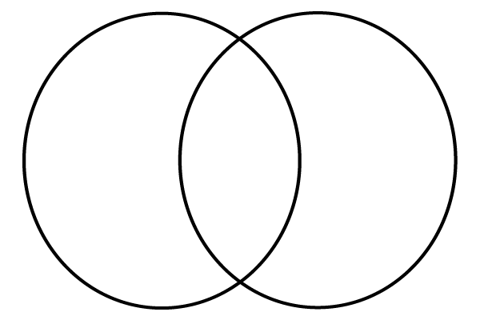

Lesson 7
The Military Revolution

Gunpowder Revolution
Knowledge of how to make gunpowder originated in China, spreading westward during the Mongol era (thirteenth and fourteenth centuries CE) to other parts of Afroeurasia. The Crusades provided an opportunity for the technology to be introduced by Muslims to Europeans and then disseminated across Europe. There was enormous pressure for competitive European states to adopt these gunpowder technologies because not to do so, would have put adversaries at an advantage.

As peoples of Afroeurasia interacted in peace and war, advances in gunpowder technology were borrowed, adapted, and diffused. The acquisition of gunpowder technologies for Europeans coincided with their overseas ventures to Africa, Asia, and the Americas.

In this lesson, students will learn that gunpowder technologies were in the possession of several states and empires, some European, many not. A “military revolution” occurred in Afroeurasia beginning about 1450. It involved innovations in weaponry, tactics, army recruitment, state funding of military buildups and wars. Some historians have called this event a “military-fiscal revolution” because it involved states finding innovative ways to raise money from their subjects and citizens in order to finance better gunpowder technologies and wars on land and sea.

Procedure
Distribute Student Handout 7.1 (Sixteenth-Century States with Gunpowder Technologies) or show it as an overhead. Students should also read about these gunpowder empires in their textbooks. Students should learn the location of these empires and discuss why they might have sought gunpowder technologies.

Students should then read Student Handout 7.2 (Gunpowder, an Explosive Issue: The Military Revolution). It traces the spread of gunpowder technology and its adoption in Europe. Students may discuss this essay in class before going on to Student Handout 7.3 (Applying Categories of History to the Military Revolution.) The directions for this activity are given on the handout.

Lesson 7
Student Handout 7.1—Sixteenth-Century States with Gunpowder Technologies

The rising cost of armies and navies during Big Era Six (1400-1800) favored those states with the largest treasuries and sources of funding. They were enabled to develop weaponry more deadly than that of their rivals. The following “gunpowder states,” some of them large empires, some not, existed during the sixteenth and seventeenth centuries. This list does not include all states that had some gunpowder weapons

England
France
Ming Dynasty in China
Mughal Empire in India
Ottoman Empire
Poland
Portugal
Russian Empire
Sa’adian Dynasty in Morocco
Safavid Empire in Persia
Spain
Tokugawa Shogunate in Japan

Lesson 7
Student Handout 7.2—Gunpowder, An Explosive Issue: The Military
Revolution

While there are many questions as to when and where gunpowder technologies first developed, many historians prefer to think of the creation of firearms not as an event but rather as a process. Historians believe that gunpowder was invented in China perhaps as early as 300 CE, with the first recipe published about 850 CE. As the people of the region of Afroeurasia interacted both in times of peace and war, the advances in gunpowder technology were borrowed, adapted, and diffused. At first, rock or metal projectiles were blown from rudimentary metal or bamboo tubes. These were the earliest guns, which later evolved into cannons, muskets, rifles, and handguns. Many societies had a hand in spreading the technology besides the Chinese, including Mongols, Arabs, and eventually Europeans. Firearms technology was known in Europe from the early fourteenth century. A manuscript of 1327 shows a drawing of an early cannon (bombard).

Student Handout 7.1 shows us that during Big Era Six several states and empires effectively used firepower to spread their territories though conquest. Europeans probably learned of the effectiveness of these weapons from Muslims, perhaps in connection with European battles with Muslim armies in Spain. Most states in Afroeurasia that knew about firearms wanted to acquire them, even though early cannon were often more effective as frightening noise-makers than as weapons. They had short ranges and little accuracy or reliability.

European states gradually gained world advantage in firearms technology, though this took until the eighteenth century. How did the Europeans gain this advantage? This question has excited historians for many years.

In the sixteenth century, however, European states did not have any serious advantage over the Ottoman empire, Russia, Persia, China, or some other states in gunpowder technology. In any case, no state could have a gunpowder army without wealth to pay for it. That is, there was a fiscal side to the Military Revolution. This term relates to finance and economics and the revenue in a state’s treasury, or “fisc.” By Big Era Six, as gunpowder weapons became more deadly, states had to compete more furiously than ever to fund and build armies. They had to find ways to finance increasingly expensive artillery, muskets, horses, wagons, troops, and fortifications.

So, how did states get the necessary funds to gain the advantage with gunpowder weaponry? Innovative sources of revenue included new kinds of taxes, customs revenues, government fees, and booty from wars. For example, the monarchs of France, England, Spain, and other European states instituted new taxes on individuals, households, sales of goods, salt, and even farmers’ plow animals. In the seventeenth century, the emperors of Russia collected at least 280 different kinds of taxes, including levies on honey, salt, bathhouses, and the contracting of third marriages.

The information presented in the introductory essay to Big Era Six also shows us that the
Americas became a bonanza of wealth for European powers that they did not have previously. The plantation complex in the Americas created huge wealth from sugar, tobacco, cotton, and indigo, and mines yielded great quantities of silver. At first, Spain benefited from exploitation of the Americas more than any other state, but England, France, and the Netherlands got into the act in the late sixteenth or early seventeenth centuries. States that could not finance costly artillery and other weapons were gradually eliminated by their more financially and politically successful rivals.

Lesson 7
Student Handout 7.3—Applying Categories of History to the Military Revolution

Historians use the terms “political,” “economic,” “social,” and “cultural” as a tool to help organize historical information and make it more understandable.

Terms
Political | Having to do with the principles and practice of government; related to gaining and winning power both within a state and regionally or globally.
Economic | Having to do with finances or monetary well-being; material wealth.
Social | Having to do with the life, welfare, and relations between human beings in a society; relationships among social classes or ethno-racial groups, or between men and women.
Culture | Having to do with the distinctive or particular beliefs, values, attitudes, practices, and traditions within a specific society.

Directions
The terms above are used to help categorize and understand human events. In this activity, you will examine some of the reasons for the Military Revolution and analyze them in terms of political, economic, social, or cultural aspects. These terms are interrelated and often work together. For example, in the modern world for a nation to have global political power, it most likely must have economic power as well. Your task is to determine whether the statements that follow about the Military Revolution relate more closely to political, economic, social, or cultural concepts. You may use more than one term in categorizing a statement, but be prepared to discuss all answers either in groups or with the whole class.

Analyze the statements below assigning one or more of the four terms. Write in the space provided:
- P if the statement reflects mostly political aspects of history.
- E for mostly economic aspects.
- S for mostly social aspects.
- C for mostly cultural aspects.

In the space below the statement, write your understanding of the term you used and how your selection of the term applies to the statement.
___1. European states accumulated wealth for military development partly by forcing American Indians and African slaves to work in silver mines and on sugar plantations.
Why did your choose the term(s) you did?

___2. The map of Europe was much changed in the sixteenth and seventeenth centuries because of the failure of some states to participate in the Military Revolution and to hang on to their territories.
Why did your choose the term(s) you did?

___3. European states entered into the trading networks of the Indian Ocean and East Asia but they did not dominate them any time before the nineteenth century.
Why did your choose the term(s) you did?

___4. Europeans, especially the British, French, and Dutch, encouraged commercial ventures by granting special charters, or sets of rights and privileges, to companies of merchants.
Why did your choose the term(s) you did?

___5. Some European nobles put aside their previous disapproval of money-making to invest in
the overseas commercial activities.
Why did your choose the term(s) you did?

___6. Rivalry and frequent European wars forced nations to create more deadly, accurate, and lighter weaponry to defend themselves or enlarge their territories.
Why did your choose the term(s) you did?

____7. Silver mines and sugar and tobacco plantations, as well as trade in other American commodities, resulted in huge increases in revenue, which was deposited in European national treasuries.
Why did your choose the term(s) you did?

___8. Afroeurasian states developed more efficient government administration to obtain more taxes from their subjects or citizens in order to keep up with the latest military technology.
Why did your choose the term(s) you did?

___9. European traders often prospered and they enjoyed high status and rewards within their societies
Why did your choose the term(s) you did?

Lesson 8
Scientific Revolution or Scientific Evolution?

Introduction
Teachers should review with students materials from Big Era Five (Patterns of Interregional Unity, 300-1500 CE), the “This Unit and the Three Essential Questions” essay, the PowerPoint Overview Presentation, and the Panorama Teaching Unit, Lessons 3 (Transfers of Products and Technology) and Lesson 5 (Scientific and Intellectual Exchange). Lesson 3 examines the transfer of technologies, goods, and ideas through trade, and includes a chart of these items. Lesson 5 includes a discussion of the concept of “Southernization,” an idea developed by the world historian Lynda Shaffer. This concept challenges the familiar claim that the making of the modern world has been a process of Westernization led exclusively by Europe and Europeans. Also in Lesson 5, many of the specific transfers are listed, including the Indian concept of zero and navigational advances.

Procedure
Assign students to read Student Handout 8 (Afroeurasian Foundations of the Scientific Revolution). This reading will serve to familiarize students with the concept that, while Western Civilization made great contributions to science, there were contributions of others. The essay examines links between European and other sources of knowledge.

On the basis of reading Student Handout 8, textbook materials, and other research sources the teacher may wish to assign, students will prepare a debate on this question: Should the term “Scientific Revolution” be replaced by the term “Scientific Evolution” to best explain the development of modern science?

To prepare the debate or discussion, students should research some of the claims made in the handout essay by using other research sources, including reliable sources on the Internet.

Scenario
Students should imagine that they have been hired by a textbook company that is considering changing the term, “Scientific Revolution” to “Scientific Evolution” in their texts so that the cumulative scientific knowledge of peoples besides Europeans can be recognized. Divide the class into groups, and assign each group one of the following discoveries to investigate. Students should examine the discoveries of both non-European and European scientists.

Students will then debate or discuss the proposition. The teacher should instruct them on how to plan and execute a debate. Students will research various topics to determine the link between non-European contributions to European scientific advances during Big Era Six. Teachers may assign their own topics to investigate or they may follow the suggestions below. Remind students that to historically trace a topic means showing a series of developments that occurred over time.

1. Glass lenses | The use of glass lenses can be traced to Ibn Firnas (ninth century) or to al-Haytham (eleventh century). The English scholar Roger Bacon (thirteenth century) mentions in his works the use of lenses to increase vision.
2. Drug chemotherapy | Muslim scholars used specific substances to destroy microbes. Al-Razi (tenth century) used mercurial compounds as antiseptics. Paul Ehrlich (nineteenth-twentieth century) is considered the originator of drug chemotherapy.
3. Concept of quarantine | Used by some cities in Europe during the Black Death and recurring outbreaks of plague (fourteenth century). Muslim physicians (nineteenth century) created isolation wards in hospitals.
4. Use of catgut sutures | Used by al-Zahrawi (eleventh century). The French surgeon Ambroise Pare (sixteenth century) is noted as the “father of scientific surgery” partly for using sutures to tie off arteries.
5. Circulatory system | Al-Razi, (tenth century), Ibn al-Nafs (thirteenth century), and Ibn al-Quff (thirteenth century) documented circulation of the blood. The English scientist William Harvey (seventeenth century) identified how the blood circulates and how the heart, arteries, and veins function.
6. Experimentation | Al-Biruni (eleventh century) wrote over 200 books in which he discussed his experiments. Galileo (seventeenth century) is known as an experimenter.
7. Theory of light as rays of color | The Muslim scientists al-Haytham (eleventh century) and Kamal al-Din (fourteenth century) noted this. Isaac Newton developed light theory (seventeenth century).

Once students complete their research, they can prepare note cards from the information they have gathered and make their presentations in the formal debate setting. Some guidance from the teacher will be needed for both preparing the debate and subsequent oral discussions.

Lesson 8
Student Handout 8—Afroeurasian Foundations of the Scientific Revolution

While most texts praise the Scientific Revolution of the 1600s and 1700s as a “European miracle,” the contributions of the rest of Afroeurasia to these scientific advances are usually given less attention or ignored entirely. While European scientific knowledge has been of great importance, there is nevertheless a link between those advances and the science that had been achieved earlier in Asia and the Muslim world.

The term “Scientific Revolution,” refers to the dramatic change in scientific thought and procedure and is commonly applied to Europe in the sixteenth and seventeenth centuries. This was a time when men of science began to question the basic explanations that past authorities had provided about how the world worked.

The Big Era Six PowerPoint presentation showed that technological innovations such as the stern-post rudder, the compass, paper, printing, the lateen sail, and gunpowder as well as geographical knowledge were diffused throughout Eurasia largely under the auspices of Islam. Through the use of these important navigational technologies along with the development of powerful firearms, the Europeans were able to impose themselves onto pre-existing trade economies to create vast commercial overseas empires under their control by the end of Big Era Six. (Review Student Handout 4.1, “Cannon to the Right of Us, Cannon to the Left of Us.”)

In the sixteenth century, Western Europe was the first region in Afroeurasia to receive a mass of new knowledge about the Americas. Western Europeans also learned a great deal about other parts of Afroeurasia. Europeans were exposed to new peoples, plants, animals, and geographical
landscapes, and they thus became a sort of clearinghouse for new geographical and cultural lore. A torrent of new information from the Americas flowed to Europe, and it had great and immediate impact on intellectual life. Information was disseminated by way of the printing press so fast that the traditional system of knowledge or dogmas could be more easily challenged.

This increased body of knowledge stimulated new scientific inquiry in Europe. But the Scientific Revolution as we understand it may not have taken root in Europe without the availability of both ancient Greek texts, which were being newly translated into Latin, as well as the invaluable body of knowledge transferred from other Afroeurasian centers of learning, notably in Southwest Asia, India, and China. In other words, the Scientific Revolution derived in large measure from the spread to western Europe of the fruits of the scientific and technological achievement in the rest of Afroeurasia over several millennia.

With this in mind, one may ask, what accounts for the persistent idea that Europeans gave science to the Islamic and Asian worlds but that it never worked the other way around? According to David Christian, the reason may be that “East Asian economic history has not been studied as intensely as that of Europe; and ever since the eighteenth century, models of Asian economic history have been shaped by images of a fundamentally static ‘Asiatic’ type of economy and society.” The reality, however, was different because the Asian economies were not only the largest in the world, but they had the highest levels of commercialization, production, metallurgy, astronomy, medicine, and navigation. Christian includes this observation by a Muslim writer, al-Jahiz, who wrote in the ninth century CE:

As regards the Indians, they are among the leaders in astronomy, mathematics . . . medicine. They have the art of carving statues and painted figures. They possess the game of chess, which is the noblest of games and requires more judgment and intelligence than any other. They make Kedah swords, and excel in their use. They have splendid music. . . . They possess a script capable of expressing the sounds of all languages, as well as many numerals. They have a great deal of poetry, many long treatises, and a deep understanding of philosophy and letters. . . . Their sound judgment and sensible habits led them to invent pins, cork, toothpicks, the drape of clothes and the dyeing of hair. . . . They were the originators of the science of firk (antidotes) by which a poison can be counteracted after it has been used, and of astronomical reckoning which was subsequently adopted by the rest of the world. When Adam descended from paradise, it was to their land that he made his way.

During the previous Big Era (Big Era Five, 300-1500 CE), Muslim cities like Baghdad, Damascus, Cairo, and Cordoba were centers of civilization. In fact, Cordoba was a vigorous city that served as a magnet for students and scholars from all over Afroeurasia, including Europe, to come and study. “In the ninth century, the library of the monastery of St. Gall was the largest in Europe. It boasted 36 volumes. At the same time, the library of Cordoba contained over 500,000!”
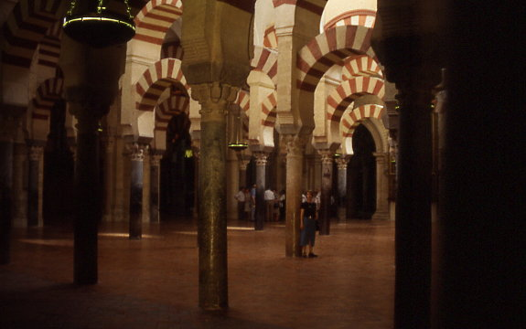

The Grand Mosque of Cordoba
8th-9th Centuries
Photo by R. Dunn

The organization of colleges (madrasas) as Muslim institutions of higher learning influenced the foundation of universities and colleges in Europe. The establishment of colleges, principally for the study of religion and law, became important in the Muslim world from the tenth century. Europeans founded institutions from the thirteenth century that took ideas from Muslim Spain on organizing colleges as centers where scholars and students lived and worked together to pursue knowledge.
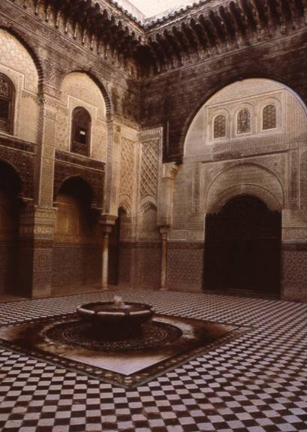
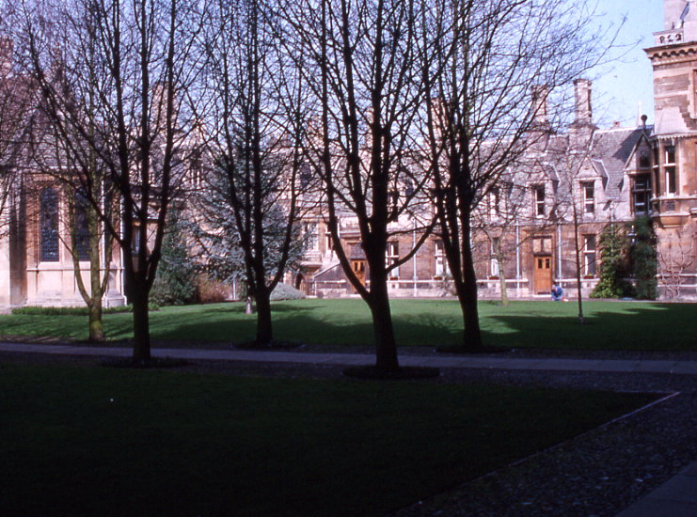
The Attarin College
Fez, Morocco
14th century
photo by R. Dunn

Christ’s College
Cambridge University
England
15th century
photo by R. Dunn

The incorporation of the Indian concept of zero, as well as the Indian decimal system, into the Arabic numbering system made mathematical problem-solving much easier. The Persian scholar al-Khwarizmi (c. 780-850 CE), who worked in Baghdad, wrote a compilation of astronomical tables and provided the groundwork for algebra. The word “algorithm” is derived from his name. Many of his books were translated into European languages, as was the work of many other Muslims scientists of the time. Muslims are also credited with discovering the principle of the pendulum, used to measure time. The transfer of these and other discoveries as well as the wealth of knowledge from the Greeks contributed greatly to the European Scientific Revolution.

In the medical field, works on optics, anesthesia, and the use of antiseptics and sutures to stop bleeding during surgery, to name a few, were translated from the Arabic. Jabir ibn-Hayam is known as the leading chemist in the Muslim world and chemical terms, such as alcohol, alembic, alkali, and elixir are all of Arabic origin. Medical knowledge was an important science in the Muslim world. As early as the 800s, Muslim doctors in Baghdad were required to pass difficult exams in order to practice medicine. The concept of a hospital is a Muslim construct and the first hospital at Cairo had over 8,000 beds. Patients with fevers, ophthalmic (eye) problems, dysentery, and surgical cases were separated. The physician Al-Razi (Al-Rhazes) is credited with discovering the origin of smallpox. He noted how one could only be struck with the disease once in one’s life. This observation suggests the recognition of an immune system and how it works to fend off certain diseases. The first school of pharmacy and the first lists and descriptions of known drugs and their side-effects were developed by Muslims. The physician and philosopher Ibn-Sina (Avicenna) wrote a medical encyclopedia with all of the knowledge that Muslim medicine had accumulated. This book was used throughout Europe until the 1600s. Hundreds of other medical works were translated into Latin and thus shared with the rest of Europe, mainly through Muslim Spain. While many of these and other contributions made the European Scientific Revolution possible, textbooks often give them little or no recognition.

Do you think that because of the cumulative character of scientific knowledge, the term “Scientific Revolution” should continue to be used to describe the advances made in Europe from the 1500’s onward? Or should the term be applied more broadly to cover the immense leap forward in the scientific arts that non-Europeans accomplished hundreds of years earlier and which contributed greatly to the advances the Europeans made in these important areas? Should the “Scientific Revolution” be looked at as more of a “Scientific Evolution” or progression from Afroeurasian science and technology that Europe adopted, adapted, and refined?
This unit and the Standards in Historical Thinking

Historical Thinking Standard 1: Chronological Thinking
The student is able to (F) reconstruct patterns of historical succession and duration.

Historical Thinking Standard 2: Historical Comprehension
The student is able to (F) utilize visual and mathematical data presented in charts, tables, pie and bar graphs, flow charts, Venn diagrams, and other graphic organizers.

Historical Thinking Standard 3: Historical Analysis and Interpretation
The student is able to (E) analyze cause-and-effect relationships and multiple causation, including the importance of the individual, the influence of ideas, and the role of chance.

Historical Thinking Standard 4: Historical Research Capabilities
The student is able to (A) formulate historical questions.

Historical Thinking Standard 5: Historical Issues-Analysis and Decision-Making
The student is able to (C) identify relevant historical antecedents.

Resources
Resources for teachers
Aftab, Macksood. “How Islam Influenced Science.” The Islamic Herald (March, 1995).

Bentley, Jerry H. and Herbert F. Ziegler. Traditions and Encounters: A Global Perspective of the Past. Vol. 2. Boston: McGraw-Hill, 2003.

Christian, David. Maps of Time: An Introduction to Big History. Berkeley: University of California Press, 2004.

Crosby, Alfred. W., Jr. The Columbian Exchange: Biological and Cultural Consequences of 1492. Westport, CT: Greenwood Press, 1972.

----. Ecological Imperialism: The Biological Expansion of Europe, 900-1900. Cambridge: Cambridge UP, 1986.

Curtin, Philip. Cross-Cultural Trade in World History. Cambridge: Cambridge UP, 1984.

Curtin, Philip D. The Rise and Fall of the Plantation Complex: Essays in Atlantic History. New York: Cambridge UP, 1990.

Diamond, Jared. Guns, Germs and Steel: The Fates of Human Societies. New York: W. W. Norton, 1999.

Dunn, Ross E. A World History: Links Across Time and Place. Evanston, IL: McDougal, Littell, 1988.

Eisen, Sidney, and Maurice Filler, ed. The Human Adventure: Readings in World History. Vol. I. New York: Harcourt Brace Jovanovich, 1964.

Ellis, Elisabeth Gaynor and Anthony Esler. World History: Connections to Today. Upper Saddle River, NJ: Prentice Hall, 1999.

Eltis, David. The Military Revolution in Sixteenth-Century Europe. New York: I. B. Tauris, 1995.

Frank, Andre Gunder ReOrient: Global Economy in the Asian Age. Berkeley: University of California Press, 1998.

Gies, Joseph and Frances. Life in a Medieval City. New York: Harper & Row, 1969.

Hollister, C. Warren, J. Sears McGee, and Gale Stokes. The West Transformed: A History of Western Civilization since 1300. Fort Worth: Harcourt College Publishers, 2000.

McNeill, William H. Plagues and Peoples. Garden City, NY: Anchor Press, 1976.

McNeill, William H. The Age of Gunpowder Empires: 1450-1800. Washington, DC: American Historical Association, 1989.

McNeill, J. R. and William H. McNeill. The Human Web: A Bird’s-Eye View of World History. New York: W. W. Norton, 2003.

Mintz, Sidney W. Sweetness and Power: The Place of Sugar in Modern History. New York: Viking, 1985.

Palmer, R. R. and Joel Colton. A History of the Modern World. New York: Alfred A. Knopf, 1971.

Parker, Geoffrey. The Military Revolution: Military Innovation and the Rise of the West, 1500-1800. 2nd ed. Cambridge: Cambridge UP, 1996

Spodek, Howard. The World’s History to 1500. Vol. 1. Englewood Cliffs, NJ: Prentice Hall, 2000.

Stannard, David E. The Conquest of the New World: American Holocaust. New York: Oxford UP, 1992.

Stavrianos, L. S. Global Rift: The Third World Comes of Age. New York: William Morrow, 1981.

Correlations to National and State Standards
National Standards for World History
Era 6: The Emergence of the First Global Age, 1450-1770. 1C: The student understands the consequences of the worldwide exchange of flora, fauna, and pathogens. 4B: The student understands the origins and consequences of the trans-Atlantic African slave trade. 6A: The student understands major global trends from 1450 to 1770. Therefore, the student is able to: Assess the impact of gunpowder weaponry and other innovations in military technology on empire-building and the world balance of naval power.

California: History-Social Science Content Standard

Grade Seven, 7.11: Students analyze political and economic change in the sixteenth, seventeenth, and eighteenth centuries (the Age of Exploration, the Enlightenment, and the Age of Reason). 1. Know the great voyages of discovery, the locations of the routes, and the influence of cartography in the development of a new European worldview. 2. Discuss the exchanges of plants, animals, technology, culture, and ideas among Europe, Africa, Asia, and the Americas in the fifteenth and sixteenth centuries and the major economic and social effects on each continent.

New York: Social Studies Resource Guide with Core Curriculum
Unit Four: the First Global Age (1450-1770), E. The encounter between Europeans and the peoples of Africa, the Americas, and Asia. Case Study: The Columbian exchange.

Texas Essential Knowledge and Skills for Social Studies
§113.33. World History Studies (c) Knowledge and skills. (23) Science, technology, and society. The student understands how major scientific and mathematical discoveries and technological innovations have affected societies throughout history. The student is expected to: (A) give examples of major mathematical and scientific discoveries and technological innovations that occurred at different periods in history and describe the changes produced by these discoveries and innovations; (B) identify new ideas in mathematics, science, and technology that occurred during the Greco-Roman, Indian, Islamic, and Chinese civilizations and trace the spread of these ideas to other civilizations.

Virginia History and Social Science Standards of Learning

WHII.4.The student will demonstrate knowledge of the impact of the European Age of Discovery and expansion into the Americas, Africa, and Asia by: d) defining the Columbian Exchange; f) describing the impact of precious metal exports from the Americas.

Illinois Learning Standards: Social Science
State Goal 16 – History. C. Understand the development of economic systems. 16.C.3c (W) Describe the impact of technology (e.g., weaponry…) in different parts of the world, 1500 - present. E. Understand Illinois, United States and world environmental history. 16.E.4a (W). Describe how cultural encounters among peoples of the world (e.g., Columbian exchange…) affected the environment, 1500 - present.

Qtd. in Philip D. Curtin, Cross-Cultural Trade in World History (Cambridge: Cambridge UP, 1984), 130.
Curtin, Cross-Cultural Trade, 128.
Qtd. in Curtin, Cross-Cultural Trade, 122.
On the Zheng He voyages, see Edward L. Dreyer, Zheng He: China and the Oceans in the Early Ming Dynasty, 1405-1433 (New York: Pearson Longman, 2007); and Louise Levathes, When China Ruled the Seas: The Treasure Fleet of the Dragon Throne, 1405-1433 (New York: Oxford UP, 1994).
Joseph and Frances Gies, Life in a Medieval City (New York: Harper and Row, 1969), 281.
R. R. Palmer and Joel Colton, A History of the Modern World (New York: Alfred Knopf, 1971), 267.
Palmer and Colton, A History of the Modern World, 268.
Jerry H. Bentley and Herbert F. Ziegler, Traditions and Encounters: A Global Perspective on the Past. 2nd ed., vol. 2 (Boston: McGraw Hill, 2003), 624.
Andre Gunder Frank, ReOrient: Global Economy in the Asian Age (Berkeley: University of California Press, 1998), 256; David Christian, Maps of Time: An Introduction to Big History (Berkeley: University of California Press, 2004), 394.
Alfred W. Crosby, Jr., The Columbian Exchange: Biological and Cultural Consequences of 1492 (Westport, CT: Greenwood Press, 1972), 182.
Crosby, Columbian Exchange, 184.
William H. McNeill, Plagues and Peoples (New York: Doubleday, 1976), 1.
McNeill, Plagues and Peoples, 211.
Christian, Maps of Time, 371.
Christian, Maps of Time, 371-2.
Macksood Aftab, “How Islam Influenced Science,” The Islamic Herald (March, 1995).

